### Custom end point

### Refrences Video

### <https://www.youtube.com/watch?v=ckpd90TyBwY&t=32s>

### 

### 

### 

### 

### 

### WordPress HTTP API

### Official documentation

### <https://developer.wordpress.org/plugins/http-api/>

### 

### 

### Output:

### 

### 

### 

### 

### 

**$args = array(**

**'headers' => array(**

**'Authorization' => 'Basic ' . base64\_encode( YOUR\_USERNAME . ':' . YOUR\_PASSWORD )**

**)**

**);**

**wp\_remote\_get( $url, $args );**

### 

### 

### 

### 

### 

### 

### 

### 

$args     = array(

    'method' => 'DELETE',

);

$response = wp\_remote\_request( 'http://some-api.com/object/to/delete', $args );

### 

### 

### 

### 

### 

### 

### 

### 

### 

### 

### 

### 

### 

### 

### 

**$url = 'https://api.twitter.com/1.1/statuses/user\_timeline.json?screen\_name=danielpataki&count=3';**

**$args = array(**

**'headers' => array(**

**'Authorization' => 'Bearer ' . $access\_token,**

**),**

**);**

**$response = wp\_remote\_get( $url, $args );**

**$tweets = json\_decode( wp\_remote\_retrieve\_body($response), true )**

**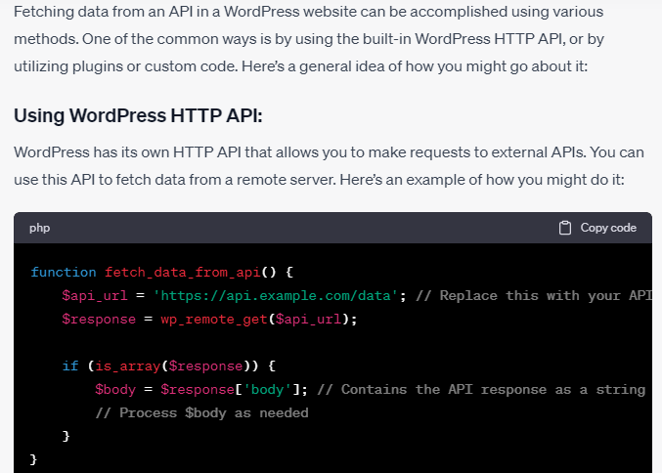**

### for adding data to an API server in WordPress using Basic Authentication or JWT token, you'll need to include the authentication details in your HTTP request headers. Here’s an example using Basic Authentication and JWT token with the WordPress HTTP API:

### 

### By JWT

### 

### 

### 

### 

### 

Fetch API in to interact with a RESTful API and want to add new data (perform a POST request),

**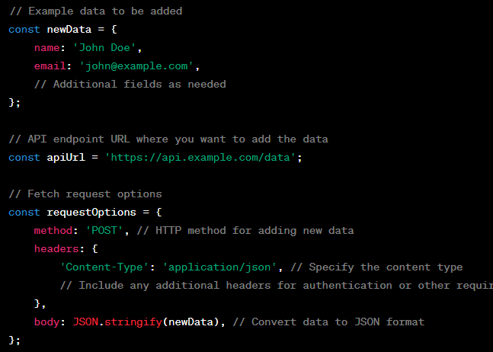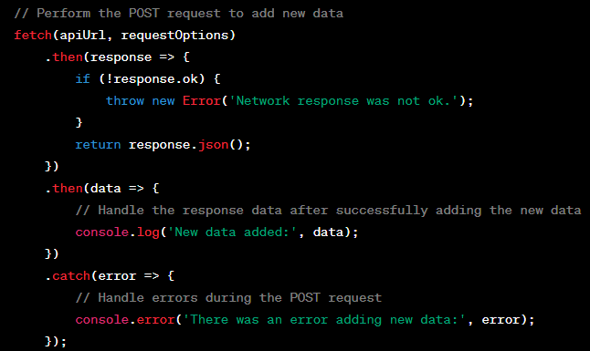**

plugin in WordPress to add custom fields for storing image URL**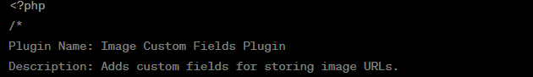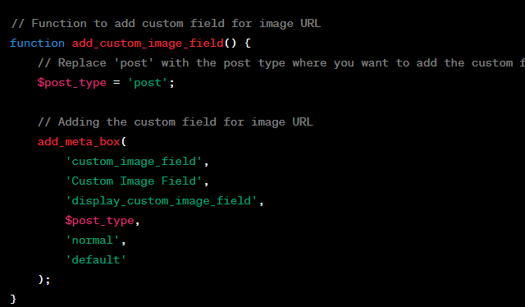**

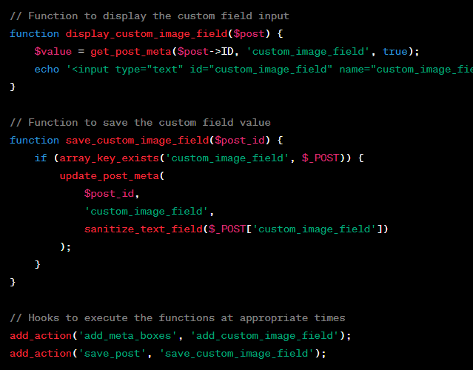



****

// Function to add custom fields for file upload and multiple checkboxes

function add\_custom\_file\_checkbox\_fields() {

    // Replace 'post' with the post type where you want to add the custom fields.

    $post\_type = 'post';

    // Adding the custom field for file upload

    add\_meta\_box(

        'custom\_file\_field',

        'Custom File Field',

        'display\_custom\_file\_field',

        $post\_type,

        'normal',

        'default'

    );

    // Adding the custom field for multiple checkboxes

    add\_meta\_box(

        'custom\_checkbox\_field',

        'Custom Checkbox Field',

        'display\_custom\_checkbox\_field',

        $post\_type,

        'normal',

        'default'

    );

}

// Function to display the file upload custom field

function display\_custom\_file\_field($post) {

    $value = get\_post\_meta($post->ID, 'custom\_file\_field', true);

    echo '<input type="file" id="custom\_file\_field" name="custom\_file\_field" />';

}

// Function to display the multiple checkboxes custom field

function display\_custom\_checkbox\_field($post) {

    $value = get\_post\_meta($post->ID, 'custom\_checkbox\_field', true);

    $options = array('Option 1', 'Option 2', 'Option 3'); // Add your checkbox options

    foreach ($options as $option) {

        $checked = in\_array($option, $value) ? 'checked' : '';

        echo '<label><input type="checkbox" name="custom\_checkbox\_field[]" value="' . esc\_attr($option) . '" ' . $checked . ' />' . esc\_html($option) . '</label><br />';

    }

}

// Function to save the custom field values

function save\_custom\_file\_checkbox\_fields($post\_id) {

    if (array\_key\_exists('custom\_file\_field', $\_FILES)) {

        // Handle file upload here

        // Example: move\_uploaded\_file($\_FILES['custom\_file\_field']['tmp\_name'], $upload\_dir . '/' . $\_FILES['custom\_file\_field']['name']);

    }

    if (array\_key\_exists('custom\_checkbox\_field', $\_POST)) {

        update\_post\_meta($post\_id, 'custom\_checkbox\_field', $\_POST['custom\_checkbox\_field']);

    }

}

// Hooks to execute the functions at appropriate times

add\_action('add\_meta\_boxes', 'add\_custom\_file\_checkbox\_fields');

add\_action('save\_post', 'save\_custom\_file\_checkbox\_fields');

**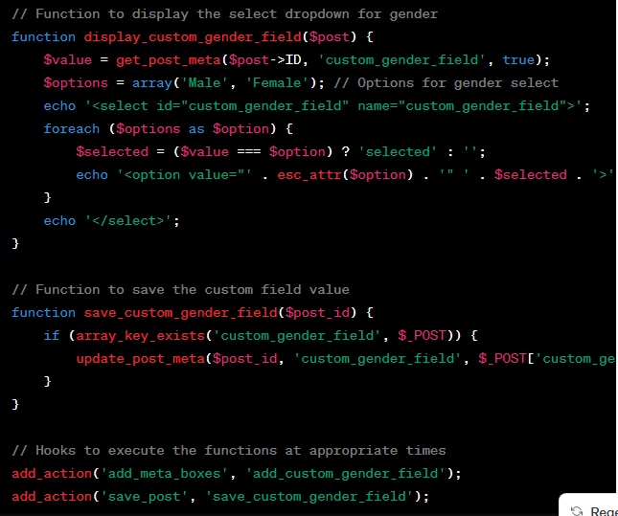**

****

****

**Wordpress Calling REST API**

[**https://www.youtube.com/watch?v=c8kBOWPKpyU**](https://www.youtube.com/watch?v=c8kBOWPKpyU)

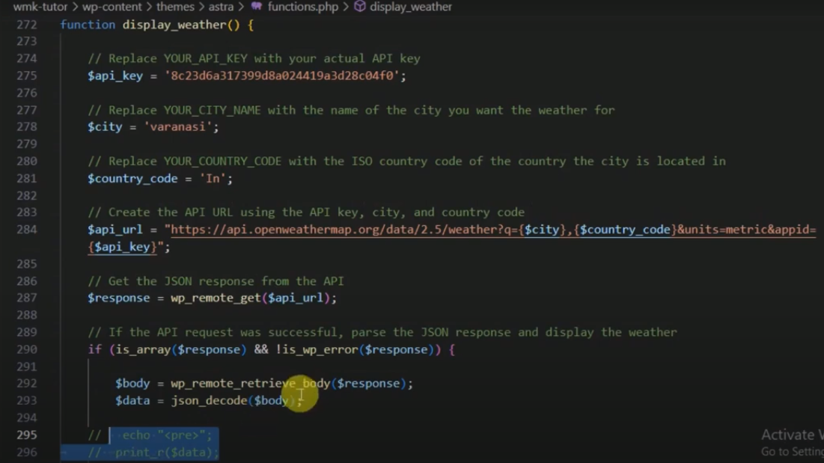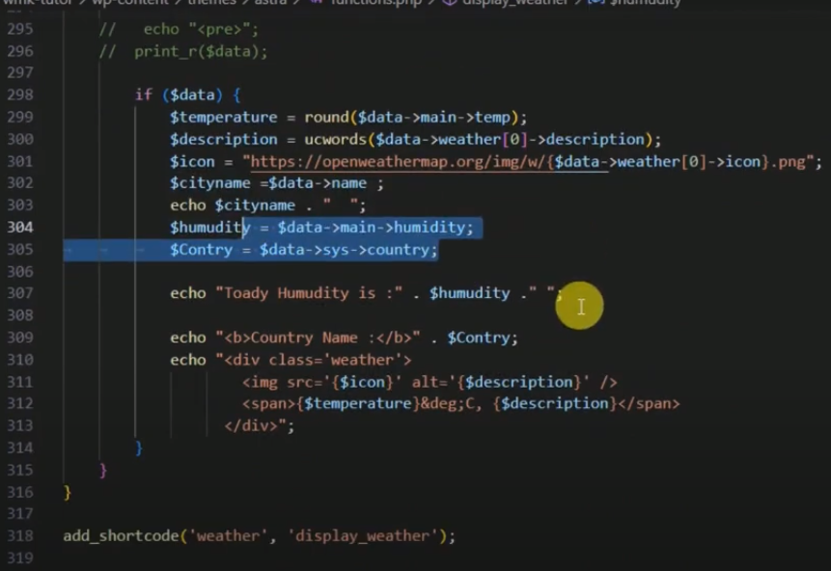

**JWT Autherntication.**

**First install JWT Autherntication plugin for REST API.**

**Second Configure plugin**

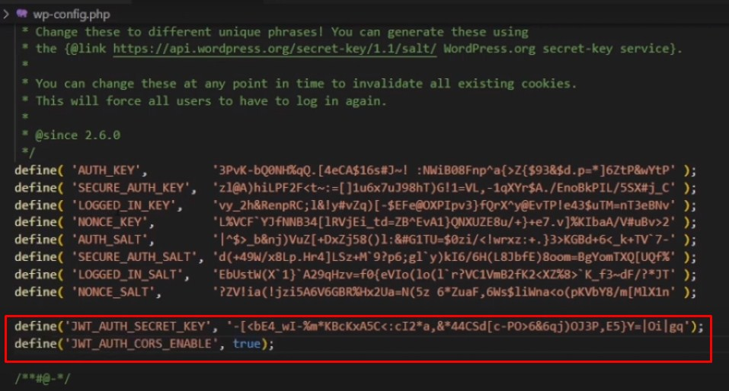

**Token Generation through Postman API Tool**

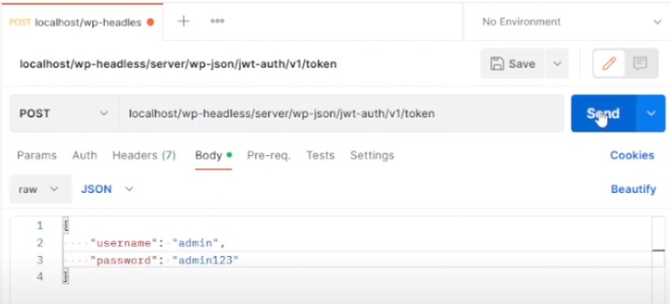

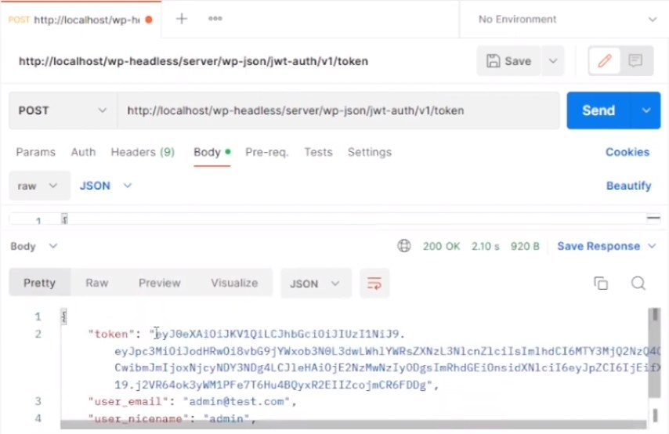

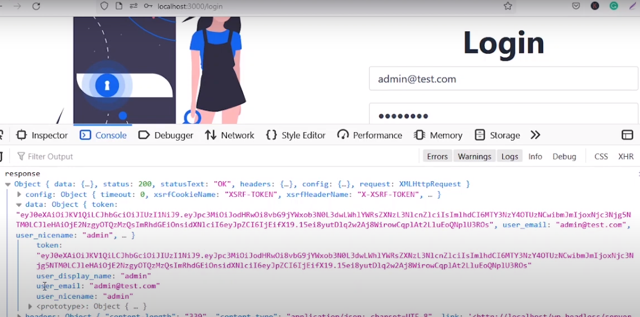

# [How to Add Custom Endpoints to WordPress API](https://artisansweb.net/how-to-add-custom-endpoints-to-wordpress-api/)

[**https://artisansweb.net/category/wordpress/**](https://artisansweb.net/category/wordpress/)

[**https://artisansweb.net/how-to-add-custom-endpoints-to-wordpress-api/**](https://artisansweb.net/how-to-add-custom-endpoints-to-wordpress-api/)

**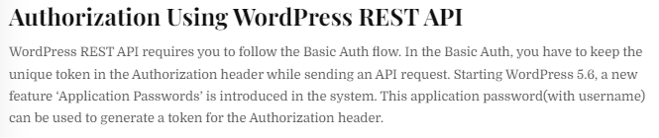**

**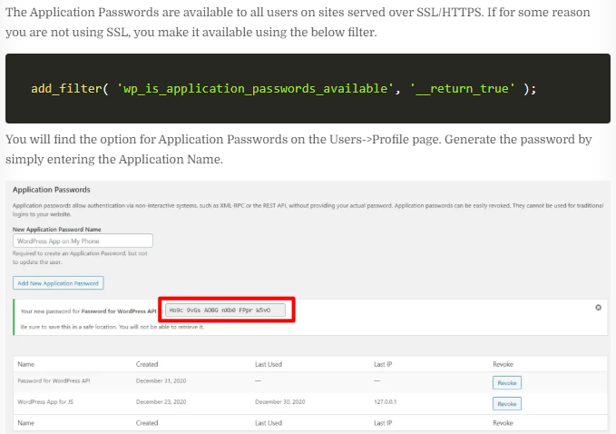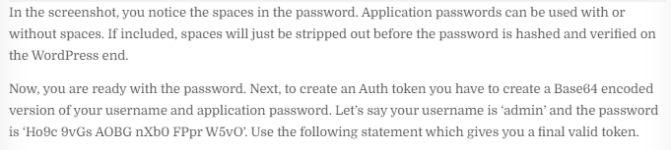**

**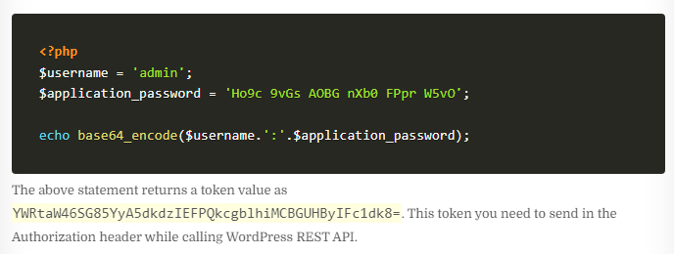**

**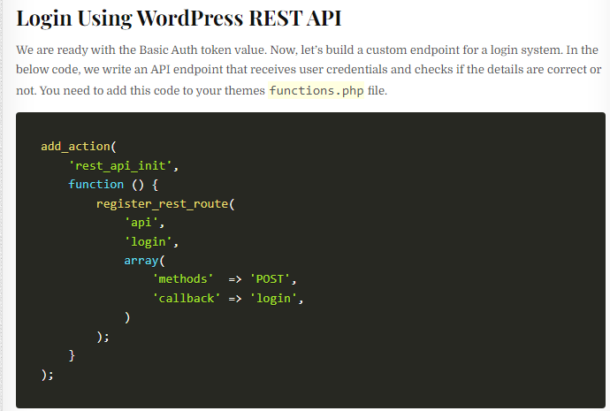**

****

**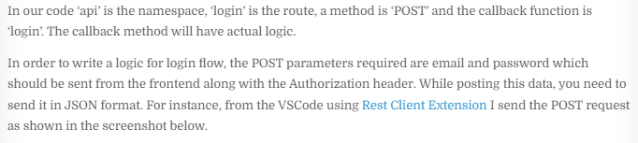**

**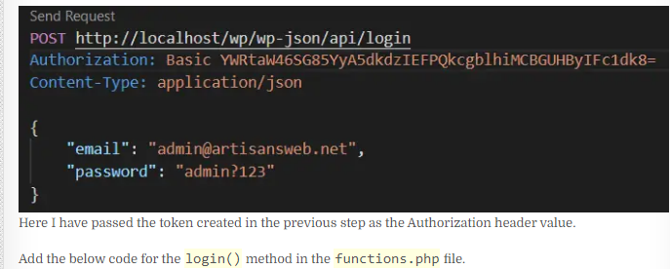**

**<?php**

**function login( WP\_REST\_Request $request ) {**

**$arr\_request = json\_decode( $request->get\_body() );**

**if ( ! empty( $arr\_request->email ) && ! empty( $arr\_request->password ) ) {**

**// this returns the user ID and other info from the user name.**

**$user = get\_user\_by( 'email', $arr\_request->email );**

**if ( ! $user ) {**

**// if the user name doesn't exist.**

**return [**

**'status' => 'error',**

**'message' => 'Wrong email address.',**

**];**

**}**

**// check the user's login with their password.**

**if ( ! wp\_check\_password( $arr\_request->password, $user->user\_pass, $user->ID ) ) {**

**// if the password is incorrect for the specified user.**

**return [**

**'status' => 'error',**

**'message' => 'Wrong password.',**

**];**

**}**

**return [**

**'status' => 'success',**

**'message' => 'User credentials are correct.',**

**];**

**} else {**

**return [**

**'status' => 'error',**

**'message' => 'Email and password are required.',**

**];**

**}**

**}**

**?>**

**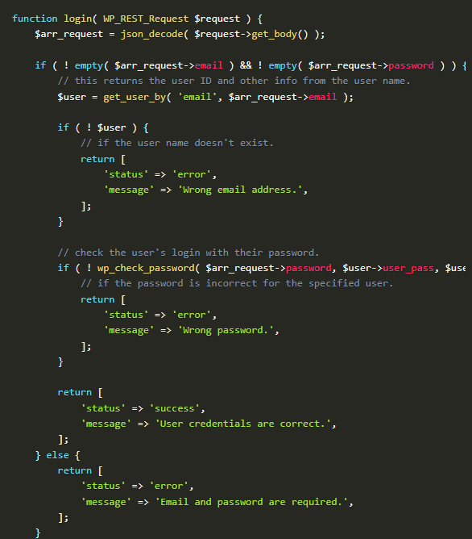**

**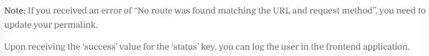**

**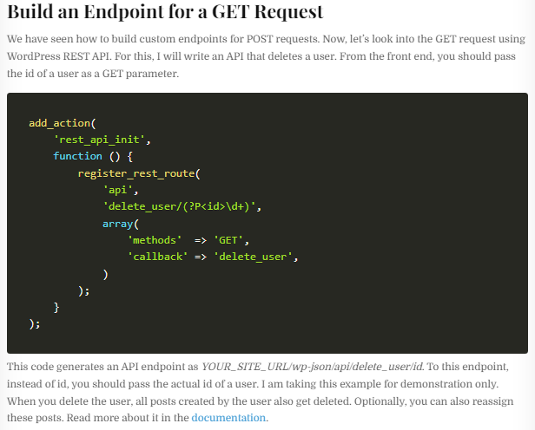**

**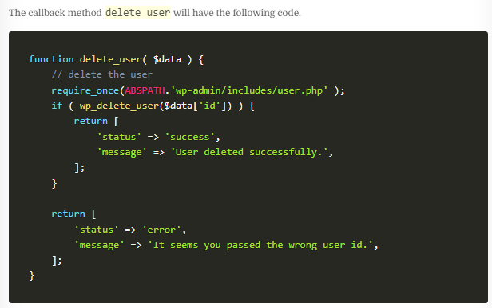**

**Custom Endpoint Tanuj para**

[**https://www.youtube.com/watch?v=-30MKlNDHrA&t=27s**](https://www.youtube.com/watch?v=-30MKlNDHrA&t=27s)

**<?php**

**/\***

**\* Plugin Name:       IWS Custom Code**

**\* Description:       Add custom code**

**\* Author:            Tanuj G. Patra**

**\* Version:           1.0.0**

**\* Requires at least: 5.2**

**\* Requires PHP:      5.6**

**\*/**

**remove\_filter('the\_excerpt', 'wpautop');**

**remove\_filter('the\_content', 'wpautop');**

**function iwsGetFeaturedImgSrc($obj, $fieldName, $request)**

**{**

**if ($obj['featured\_media']) {**

**$img = wp\_get\_attachment\_image\_src($obj['featured\_media'], 'full');**

**return $img[0];**

**}**

**return false;**

**}**

**function iwsCreatePostWithFeaturedImg($request) {**

**$params = $request->get\_params();**

**$title = sanitize\_text\_field($params['title']);**

**$content = wp\_kses\_post($params['content']);**

**$post = [**

**'post\_title' => $title,**

**'post\_content' => $content,**

**'post\_status' => 'publish',**

**'post\_type' => 'post'**

**];**

**$postId = wp\_insert\_post($post);**

**// Image upload**

**if (isset($\_FILES['featured\_img']) && !empty($\_FILES)) {**

**$img = $\_FILES['featured\_img'];**

**$img\_name = str\_replace(' ', '-', $title.'.'.explode('.', $img['name'])[1]);**

**$file = wp\_upload\_bits($img\_name, null, file\_get\_contents($img['tmp\_name']));**

**$fileType = wp\_check\_filetype($file['file'], null);**

**$attachmentData = [**

**'post\_mime\_type' => $fileType['type'],**

**'post\_title' => $img\_name,**

**'post\_content' => '',**

**'post\_status' => 'inherit'**

**];**

**$attachmentId = wp\_insert\_attachment($attachmentData, $file['file'], $postId);**

**set\_post\_thumbnail($postId, $attachmentId);**

**}**

**return [**

**'status' => 'success',**

**'post' => $postId**

**];**

**}**

**function iwsRegisterUser($request) {**

**$params = $request->get\_params();**

**$username = sanitize\_text\_field($params['username']);**

**$email = wp\_kses\_post($params['email']);**

**$password = wp\_kses\_post($params['password']);**

**$user = wp\_create\_user($username, $password, $email);**

**if (is\_wp\_error($user)) {**

**return ['status' => 'REGISTER\_FAILED', 'error', $user->get\_error\_message()];**

**}**

**return [**

**'user' => $user,**

**'starus' => 201,**

**];**

**}**

**add\_action('rest\_api\_init', function () {**

**register\_rest\_field('post', 'featured\_src', [**

**'get\_callback' => 'iwsGetFeaturedImgSrc',**

**]);**

**register\_rest\_route('wp/v2', 'create-post', [**

**'methods' => "POST",**

**'callback' => 'iwsCreatePostWithFeaturedImg'**

**]);**

**register\_rest\_route('wp/v2', 'register', [**

**'methods' => "POST",**

**'callback' => 'iwsRegisterUser'**

**]);**

**});**

**Wordpress official Custom Endpoint Method**

<https://developer.wordpress.org/rest-api/requests/>

**// Register our individual books endpoint.**

**function prefix\_register\_book\_route() {**

**register\_rest\_route( 'my-namespace/v1', '/books/(?P<id>\d+)', array(**

**// Supported methods for this endpoint. WP\_REST\_Server::READABLE translates to GET.**

**'methods' => WP\_REST\_Server::READABLE,**

**// Register the callback for the endpoint.**

**'callback' => 'prefix\_get\_book',**

**) );**

**}**

**add\_action( 'rest\_api\_init', 'prefix\_register\_book\_route' );**

**/\*\***

**\* Our registered endpoint callback. Notice how we are passing in $request as an argument.**

**\* By default, the WP\_REST\_Server will pass in the matched request object to our callback.**

**\***

**\* @param WP\_REST\_Request $request The current matched request object.**

**\*/**

**function prefix\_get\_book( $request ) {**

**// Here we are accessing the path variable 'id' from the $request.**

**$book = prefix\_get\_the\_book( $request['id'] );**

**return rest\_ensure\_response( $book );**

**}**

**// A simple function that grabs a book title from our books by ID.**

**function prefix\_get\_the\_book( $id ) {**

**$books = array(**

**'Design Patterns',**

**'Clean Code',**

**'Refactoring',**

**'Structure and Interpretation of Computer Programs',**

**);**

**$book = '';**

**if ( isset( $books[ $id ] ) ) {**

**// Grab the matching book.**

**$book = $books[ $id ];**

**} else {**

**// Error handling.**

**return new WP\_Error( 'rest\_not\_found', esc\_html\_\_( 'The book does not exist', 'my-text-domain' ), array( 'status' => 404 ) );**

**}**

**return $book;**

**}**

Query parameters exist in the query string portion of a URI. The query string portion of a URI in https://ourawesomesite.com/wp-json/my-namespace/v1/books?per\_page=2&genre=fiction` is?per\_page=2&genre=fiction. The query string is started by the '?' character, the different values within the query string are separated by the '&' character. We specified two parameters in our query string;per\_pageandgenre. In our endpoint we would want to grab only two books from the fiction genre. We could access those values in a callback like this:$request[‘per\_page’], and$request[‘genre’]` ( assuming $request is the name of the argument we are using ). If you are familiar with PHP you have probably used query parameters in your web applications.

**// Register our individual books endpoint.**

**function prefix\_register\_book\_route() {**

**register\_rest\_route( 'my-namespace/v1', '/books/(?P<id>\d+)', array(**

**// Supported methods for this endpoint. WP\_REST\_Server::READABLE translates to GET.**

**'methods' => WP\_REST\_Server::READABLE,**

**// Register the callback for the endpoint.**

**'callback' => 'prefix\_get\_book',**

**) );**

**}**

**add\_action( 'rest\_api\_init', 'prefix\_register\_book\_route' );**

**/\*\***

**\* Our registered endpoint callback. Notice how we are passing in $request as an argument.**

**\* By default, the WP\_REST\_Server will pass in the matched request object to our callback.**

**\***

**\* @param WP\_REST\_Request $request The current matched request object.**

**\*/**

**function prefix\_get\_book( $request ) {**

**// Here we are accessing the path variable 'id' from the $request.**

**$book = prefix\_get\_the\_book( $request['id'] );**

**return rest\_ensure\_response( $book );**

**}**

**// A simple function that grabs a book title from our books by ID.**

**function prefix\_get\_the\_book( $id ) {**

**$books = array(**

**'Design Patterns',**

**'Clean Code',**

**'Refactoring',**

**'Structure and Interpretation of Computer Programs',**

**);**

**$book = '';**

**if ( isset( $books[ $id ] ) ) {**

**// Grab the matching book.**

**$book = $books[ $id ];**

**} else {**

**// Error handling.**

**return new WP\_Error( 'rest\_not\_found', esc\_html\_\_( 'The book does not exist', 'my-text-domain' ), array( 'status' => 404 ) );**

**}**

**return $book;**

**}**

**Custom end point**

<https://developer.wordpress.org/rest-api/extending-the-rest-api/adding-custom-endpoints/>

**<?php**

**add\_action( 'rest\_api\_init', function () {**

**register\_rest\_route( 'myplugin/v1', '/author/(?P<id>\d+)', array(**

**'methods' => 'GET',**

**'callback' => 'my\_awesome\_func',**

**) );**

**} );**

## [Creating Endpoints](https://developer.wordpress.org/rest-api/extending-the-rest-api/routes-and-endpoints/#creating-endpoints)

<https://developer.wordpress.org/rest-api/extending-the-rest-api/routes-and-endpoints/>

<https://developer.wordpress.org/rest-api/reference/categories/>

<https://developer.wordpress.org/rest-api/reference/pages/>

<https://developer.wordpress.org/rest-api/reference/posts/>

<https://developer.wordpress.org/rest-api/reference/application-passwords/>

If we wanted to create an endpoint that would return the phrase “Hello World, this is the WordPress REST API” when it receives a GET request, we would first need to register the route for that endpoint. To register routes you should use the register\_rest\_route() function. It needs to be called on the rest\_api\_init action hook. register\_rest\_route() handles all of the mapping for routes to endpoints. Let’s try to create a “Hello World, this is the WordPress REST API” route.

**/\*\***

**\* This is our callback function that embeds our phrase in a WP\_REST\_Response**

**\*/**

**function prefix\_get\_endpoint\_phrase() {**

**// rest\_ensure\_response() wraps the data we want to return into a WP\_REST\_Response, and ensures it will be properly returned.**

**return rest\_ensure\_response( 'Hello World, this is the WordPress REST API' );**

**}**

**/\*\***

**\* This function is where we register our routes for our example endpoint.**

**\*/**

**function prefix\_register\_example\_routes() {**

**// register\_rest\_route() handles more arguments but we are going to stick to the basics for now.**

**register\_rest\_route( 'hello-world/v1', '/phrase', array(**

**// By using this constant we ensure that when the WP\_REST\_Server changes our readable endpoints will work as intended.**

**'methods'  => WP\_REST\_Server::READABLE,**

**// Here we register our callback. The callback is fired when this endpoint is matched by the WP\_REST\_Server class.**

**'callback' => 'prefix\_get\_endpoint\_phrase',**

**) );**

**}**

**add\_action( 'rest\_api\_init', 'prefix\_register\_example\_routes' );**

### [HTTP Methods](https://developer.wordpress.org/rest-api/extending-the-rest-api/routes-and-endpoints/#http-methods)

HTTP methods are sometimes referred to as HTTP verbs. They are simply just different ways to communicate via HTTP. The main ones used by the WordPress REST API are:

* **GET should be used for retrieving data from the API.**
* **POST should be used for creating new resources (i.e users, posts, taxonomies).**
* **PUT should be used for updating resources.**
* **DELETE should be used for deleting resources.**
* **OPTIONS should be used to provide context about our resources.**

### Vishal API Creation

### C:\Users\Rajiv\Desktop\Screenshot_1.jpg

### C:\Users\Rajiv\Desktop\Screenshot_2.jpg

### C:\Users\Rajiv\Desktop\Screenshot_4.jpg

### C:\Users\Rajiv\Desktop\Screenshot_5.jpg

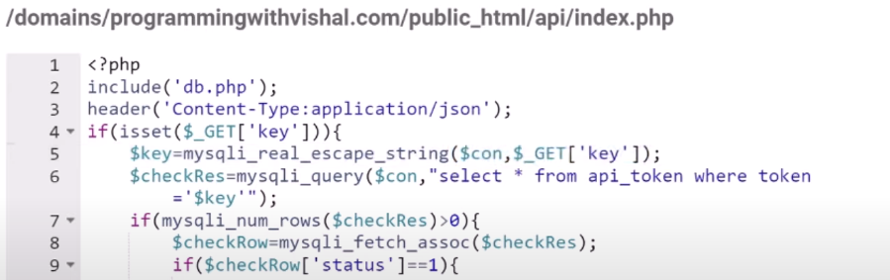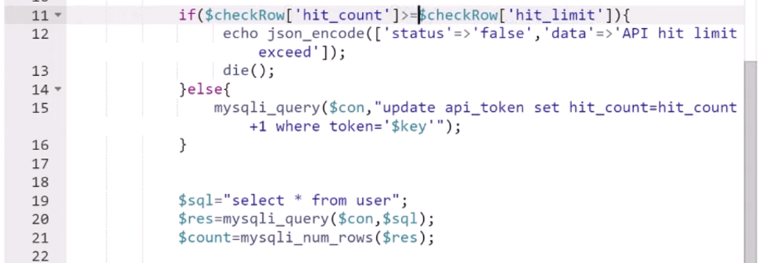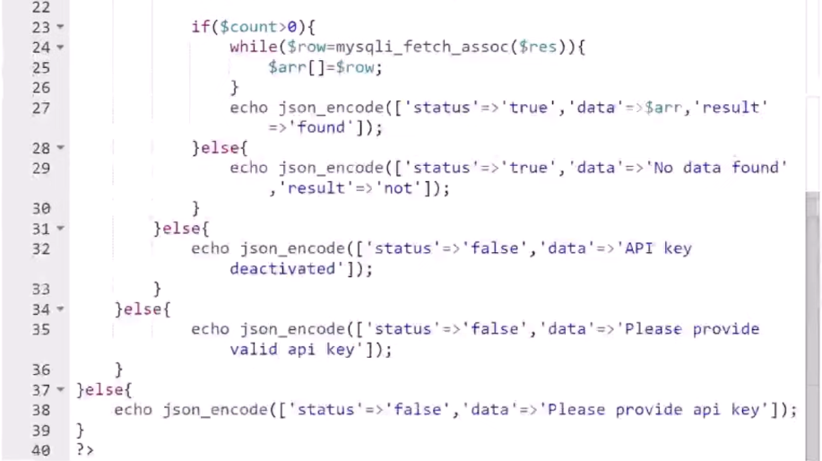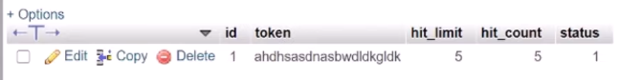

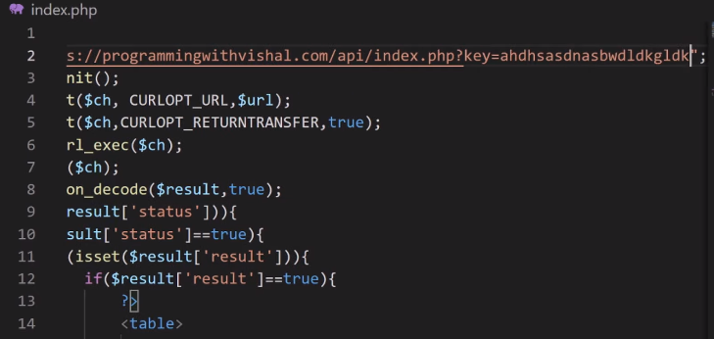

### Vishal Complete API CRED with Token Auth

### 

### 

**API token.php** 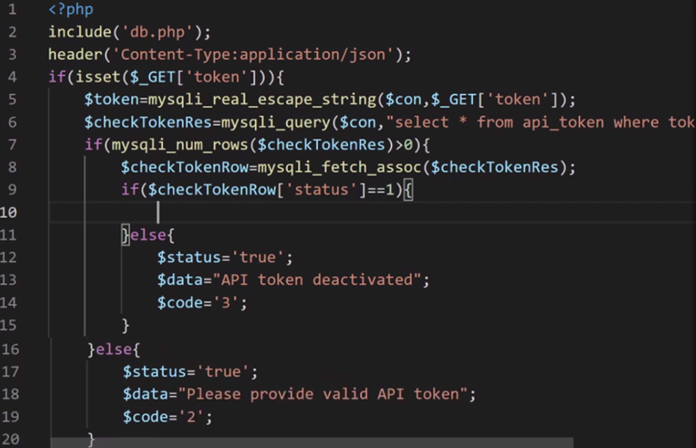

**API insert.php** 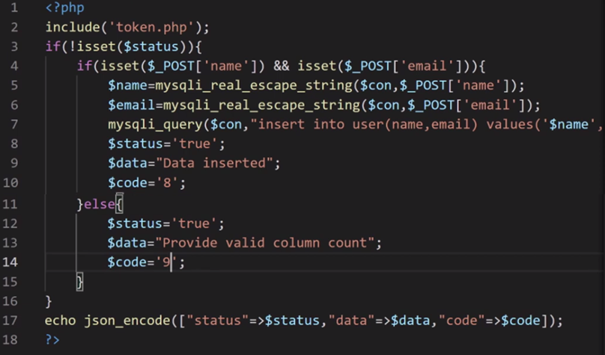

**API delete.php**

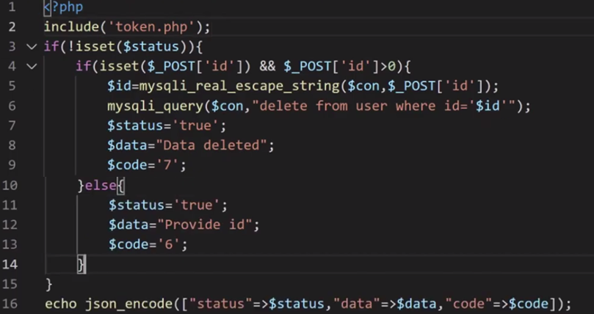

**Consumer delete.php**

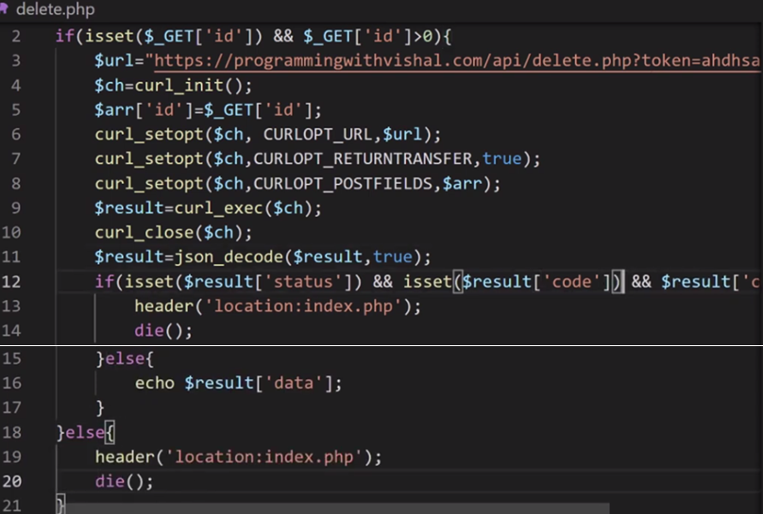

**API db.php**

**<?php**

**$con=mysqli\_connect('localhost','username','password','db');**

**?>**

**API token.php**

**<?php**

**include('db.php');**

**header('Content-Type:application/json');**

**if(isset($\_GET['token'])){**

**$token=mysqli\_real\_escape\_string($con,$\_GET['token']);**

**$checkTokenRes=mysqli\_query($con,"select \* from api\_token where token='$token'");**

**if(mysqli\_num\_rows($checkTokenRes)>0){**

**$checkTokenRow=mysqli\_fetch\_assoc($checkTokenRes);**

**if($checkTokenRow['status']==1){**

**}else{**

**$status='true';**

**$data="API token deactivated";**

**$code='3';**

**}**

**}else{**

**$status='true';**

**$data="Please provide valid API token";**

**$code='2';**

**}**

**}else{**

**$status='true';**

**$data="Please provide API token";**

**$code='1';**

**}**

**?>**

**API index.php**

**<?php**

**include('token.php');**

**if(!isset($status)){**

**$sql="select \* from user ";**

**if(isset($\_GET['id']) && $\_GET['id']>0){**

**$id=mysqli\_real\_escape\_string($con,$\_GET['id']);**

**$sql.=" where id='$id'";**

**}**

**$sqlRes=mysqli\_query($con,$sql);**

**if(mysqli\_num\_rows($sqlRes)>0){**

**$data=[];**

**while($row=mysqli\_fetch\_assoc($sqlRes)){**

**$data[]=$row;**

**}**

**$status='true';**

**$code='5';**

**}else{**

**$status='true';**

**$data="Data not found";**

**$code='4';**

**}**

**}**

**echo json\_encode(["status"=>$status,"data"=>$data,"code"=>$code]);**

**?>**

**API delete.php**

**<?php**

**include('token.php');**

**if(!isset($status)){**

**if(isset($\_POST['id']) && $\_POST['id']>0){**

**$id=mysqli\_real\_escape\_string($con,$\_POST['id']);**

**mysqli\_query($con,"delete from user where id='$id'");**

**$status='true';**

**$data="Data deleted";**

**$code='7';**

**}else{**

**$status='true';**

**$data="Provide id";**

**$code='6';**

**}**

**}**

**echo json\_encode(["status"=>$status,"data"=>$data,"code"=>$code]);**

**?>**

**API manage\_form.php**

**<?php**

**include('token.php');**

**if(!isset($status)){**

**if(isset($\_POST['name']) && isset($\_POST['email'])){**

**$name=mysqli\_real\_escape\_string($con,$\_POST['name']);**

**$email=mysqli\_real\_escape\_string($con,$\_POST['email']);**

**if(isset($\_GET['id']) && $\_GET['id']>0){**

**$id=mysqli\_real\_escape\_string($con,$\_GET['id']);**

**mysqli\_query($con,"update user set name='$name', email='$email' where id='$id'");**

**$data="Data updated";**

**$code='10';**

**}else{**

**mysqli\_query($con,"insert into user(name,email) values('$name','$email')");**

**$data="Data inserted";**

**$code='8';**

**}**

**$status='true';**

**}else{**

**$status='true';**

**$data="Provide valid column count";**

**$code='9';**

**}**

**}**

**echo json\_encode(["status"=>$status,"data"=>$data,"code"=>$code]);**

**?>**

**API Respone Code**

**1=>Please provide API token**

**2=>Please provide valid API token**

**3=>API token deactivated**

**4=>Data not found**

**5=>Data Return**

**6=>Provide id**

**7=>Data deleted**

**8=>Data Inserted**

**9=>Provide valid column count**

**10=>Data updated**

**Consumer form.php**

**<?php**

**$msg="";**

**$name="";**

**$email="";**

**if(isset($\_POST['submit'])){**

**$arr['name']=$\_POST['name'];**

**$arr['email']=$\_POST['email'];**

**$id="";**

**if(isset($\_GET['id']) && $\_GET['id']>0){**

**$id=$\_GET['id'];**

**}**

**$url="api\_url/manage\_form.php?token=ahdhsasdnasbwdldkgldk&id=".$id;**

**$ch=curl\_init();**

**curl\_setopt($ch, CURLOPT\_URL,$url);**

**curl\_setopt($ch,CURLOPT\_RETURNTRANSFER,true);**

**curl\_setopt($ch,CURLOPT\_POSTFIELDS,$arr);**

**$result=curl\_exec($ch);**

**curl\_close($ch);**

**$result=json\_decode($result,true);**

**$msg=$result['data'];**

**}**

**if(isset($\_GET['id']) && $\_GET['id']>0){**

**$url="https://programmingwithvishal.com/api/index.php?token=ahdhsasdnasbwdldkgldk&id=".$\_GET['id'];**

**$ch=curl\_init();**

**curl\_setopt($ch, CURLOPT\_URL,$url);**

**curl\_setopt($ch,CURLOPT\_RETURNTRANSFER,true);**

**$result=curl\_exec($ch);**

**curl\_close($ch);**

**$result=json\_decode($result,true);**

**if(isset($result['status']) && isset($result['code']) && $result['code']==5){**

**$name=$result['data']['0']['name'];**

**$email=$result['data']['0']['email'];**

**}else{**

**header('location:index.php');**

**die();**

**}**

**}**

**?>**

**<!DOCTYPE html>**

**<html lang="en">**

**<head>**

**<meta charset="utf-8">**

**<title>API Crud Operation</title>**

**<meta name="viewport" content="width=device-width, initial-scale=1">**

**<link rel="stylesheet" href="https://maxcdn.bootstrapcdn.com/bootstrap/3.4.1/css/bootstrap.min.css">**

**<script src="https://ajax.googleapis.com/ajax/libs/jquery/3.5.1/jquery.min.js"></script>**

**<script src="https://maxcdn.bootstrapcdn.com/bootstrap/3.4.1/js/bootstrap.min.js"></script>**

**<link rel="stylesheet" href="https://fonts.googleapis.com/icon?family=Material+Icons">**

**<link rel="stylesheet" href="https://maxcdn.bootstrapcdn.com/font-awesome/4.7.0/css/font-awesome.min.css">**

**<link rel="stylesheet" href="css/style.css">**

**</head>**

**<body>**

**<div class="container-xl">**

**<div class="table-responsive">**

**<div class="table-wrapper">**

**<div class="table-title">**

**<div class="row">**

**<div class="col-sm-5">**

**<h2>Manage User</h2>**

**</div>**

**<div class="col-sm-7">**

**<a href="index.php" class="btn btn-secondary"><i class="material-icons arrow\_back">&#xe5c4;</i> <span>Back</span></a>**

**</div>**

**</div>**

**</div>**

**</div>**

**</div>**

**<div class="row" id="form\_bg">**

**<?php echo $msg?>**

**<form method="post">**

**<div class="col-sm-4">**

**<div class="form-group">**

**<input type="name" class="form-control" id="name" name="name" placeholder="Enter name" required value="<?php echo $name?>">**

**</div>**

**</div>**

**<div class="col-sm-4">**

**<div class="form-group">**

**<input type="email" class="form-control" id="nombre" name="email" placeholder="Enter email" required value="<?php echo $email?>">**

**</div>**

**</div>**

**<div class="col-sm-1">**

**<div class="form-group">**

**<input type="submit" value="Submit" class="btn btn-info btn-block" name="submit">**

**</div>**

**</div>**

**</form>**

**</div>**

**</div>**

**</body>**

**</html>**

**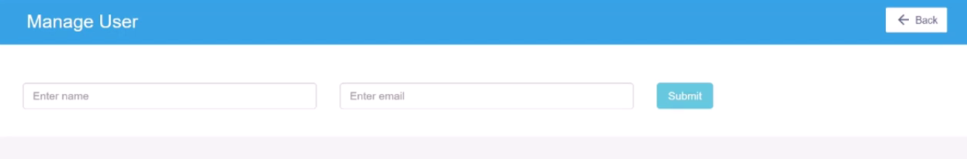**

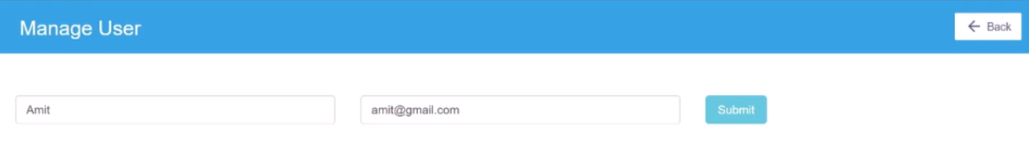

**Consumer index.php**

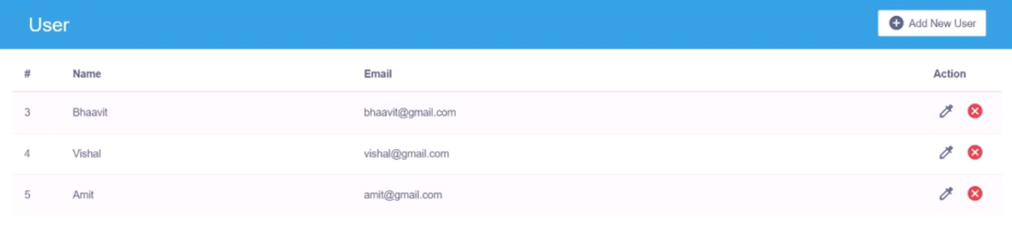

**<?php**

**$url="api\_url/index.php?token=ahdhsasdnasbwdldkgldk";**

**$ch=curl\_init();**

**curl\_setopt($ch, CURLOPT\_URL,$url);**

**curl\_setopt($ch,CURLOPT\_RETURNTRANSFER,true);**

**$result=curl\_exec($ch);**

**curl\_close($ch);**

**$result=json\_decode($result,true);**

**?>**

**<!DOCTYPE html>**

**<html lang="en">**

**<head>**

**<meta charset="utf-8">**

**<title>API Crud Operation</title>**

**<meta name="viewport" content="width=device-width, initial-scale=1">**

**<link rel="stylesheet" href="https://maxcdn.bootstrapcdn.com/bootstrap/3.4.1/css/bootstrap.min.css">**

**<script src="https://ajax.googleapis.com/ajax/libs/jquery/3.5.1/jquery.min.js"></script>**

**<script src="https://maxcdn.bootstrapcdn.com/bootstrap/3.4.1/js/bootstrap.min.js"></script>**

**<link rel="stylesheet" href="https://fonts.googleapis.com/icon?family=Material+Icons">**

**<link rel="stylesheet" href="https://maxcdn.bootstrapcdn.com/font-awesome/4.7.0/css/font-awesome.min.css">**

**<link rel="stylesheet" href="css/style.css">**

**<script>**

**$(document).ready(function(){**

**$('[data-toggle="tooltip"]').tooltip();**

**});**

**</script>**

**</head>**

**<body>**

**<div class="container-xl">**

**<div class="table-responsive">**

**<div class="table-wrapper">**

**<div class="table-title">**

**<div class="row">**

**<div class="col-sm-5">**

**<h2>User</h2>**

**</div>**

**<div class="col-sm-7">**

**<a href="form.php" class="btn btn-secondary"><i class="material-icons">&#xE147;</i> <span>Add New User</span></a>**

**</div>**

**</div>**

**</div>**

**<?php**

**if(isset($result['status']) && isset($result['code']) && $result['code']==5){**

**?>**

**<table class="table table-striped table-hover">**

**<thead>**

**<tr>**

**<th>#</th>**

**<th>Name</th>**

**<th>Email</th>**

**<th>Action</th>**

**</tr>**

**</thead>**

**<tbody>**

**<?php**

**foreach($result['data'] as $list){**

**?>**

**<tr>**

**<td><?php echo $list['id']?></td>**

**<td><?php echo $list['name']?></a></td>**

**<td><?php echo $list['email']?></td>**

**<td>**

**<a href="form.php?id=<?php echo $list['id']?>" class="edit" title="Edit"><i class="material-icons colorize">&#xe3b8;</i></a>**

**<a href="delete.php?id=<?php echo $list['id']?>" class="delete" title="Delete" ><i class="material-icons">&#xE5C9;</i></a>**

**</td>**

**</tr>**

**<?php**

**}**

**?>**

**</tbody>**

**</table>**

**<?php**

**}else{**

**echo $result['data'];**

**}**

**?>**

**</div>**

**</div>**

**</div>**

**</body>**

**</html>**

**Consumer delete.php**

**<?php**

**if(isset($\_GET['id']) && $\_GET['id']>0){**

**$url="api\_url/delete.php?token=ahdhsasdnasbwdldkgldk";**

**$ch=curl\_init();**

**$arr['id']=$\_GET['id'];**

**curl\_setopt($ch, CURLOPT\_URL,$url);**

**curl\_setopt($ch,CURLOPT\_RETURNTRANSFER,true);**

**curl\_setopt($ch,CURLOPT\_POSTFIELDS,$arr);**

**$result=curl\_exec($ch);**

**curl\_close($ch);**

**$result=json\_decode($result,true);**

**if(isset($result['status']) && isset($result['code']) && $result['code']==7){**

**header('location:index.php');**

**die();**

**}else{**

**echo $result['data'];**

**}**

**}else{**

**header('location:index.php');**

**die();**

**}**

**?>**

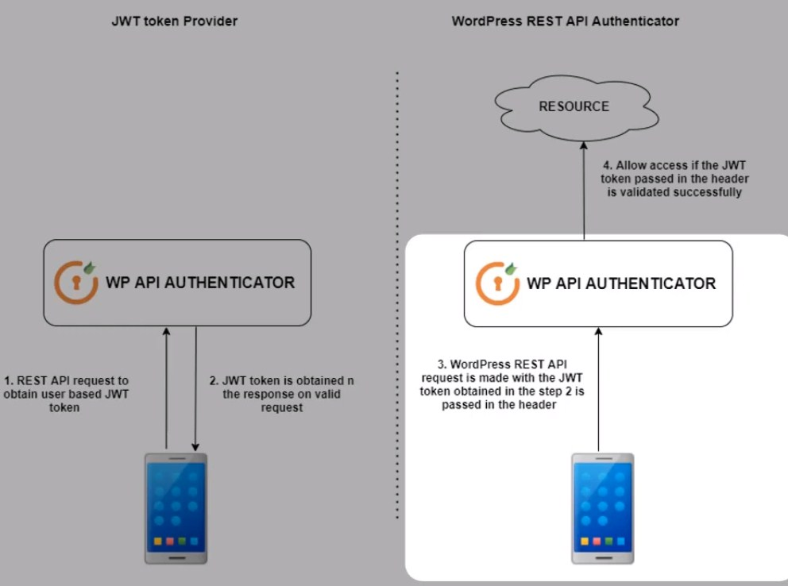

Rest API basic authentication in WordPress

In WordPress, you can use the HTTP API to make requests to a REST API that requires basic authentication. You can use the wp\_remote\_request() function with the appropriate authentication headers. For instance:

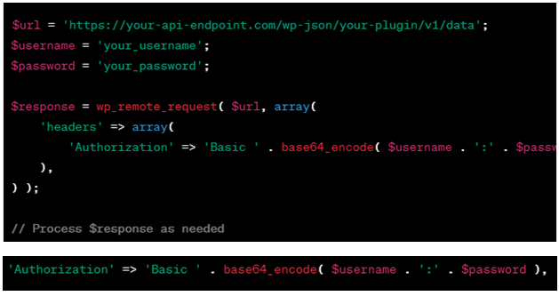

Jwt token authentication in rest API in WordPress

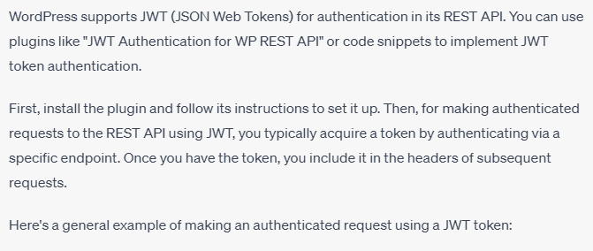

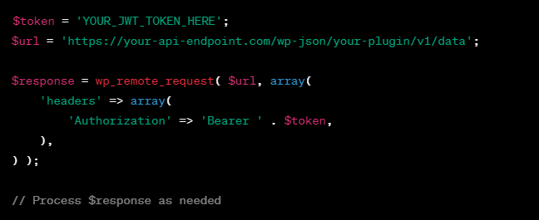

Basic authentication in PHP involves sending an HTTP request with the appropriate headers that include a username and password. Here's an example using PHP's cURL, a popular way to make HTTP requests:

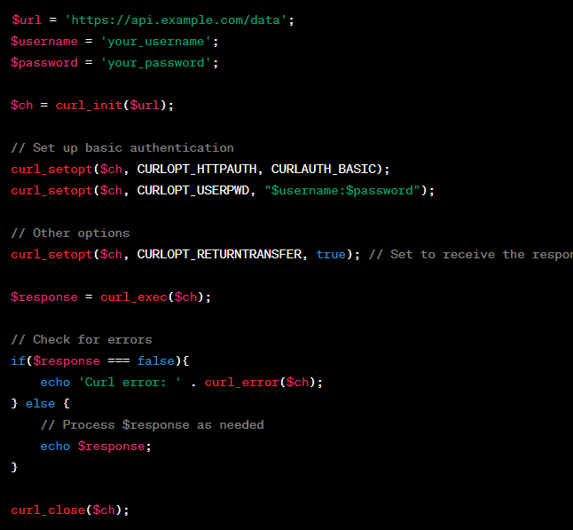

To fetch all posts from a WordPress site using the REST API, you can make a GET request to the wp/v2/posts endpoint. Here's an example using PHP's cURL:

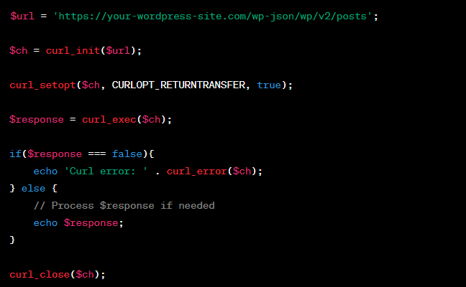

By wordpress

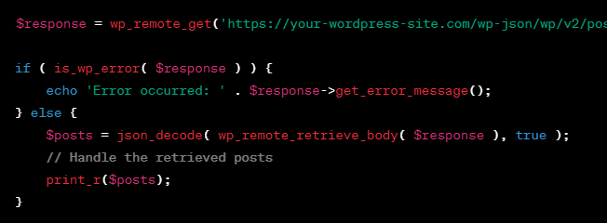

By Jquery method, To fetch all posts from a WordPress site using the REST API,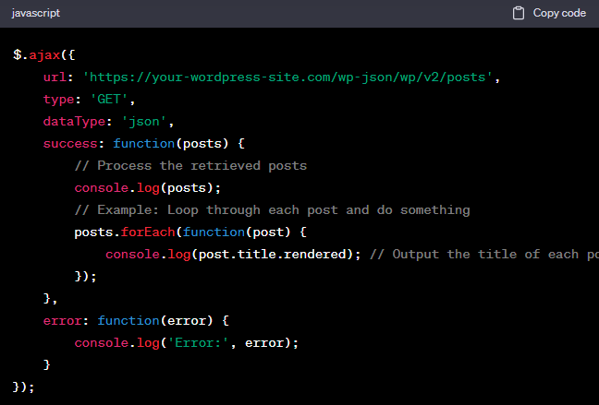

How to add new post in wordpress by rest api

Adding a new post in WordPress using the REST API involves sending a POST request to the wp/v2/posts endpoint with the necessary post data. You'll need to include specific headers, authentication, and the post content in your request.

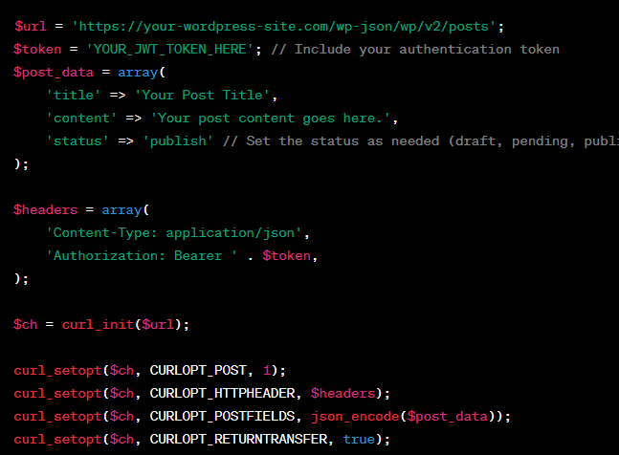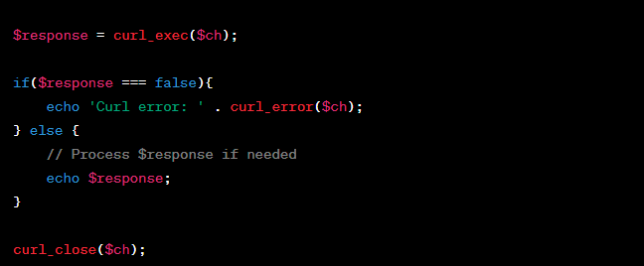

How to add new post in wordpress by rest api by jquery ajax

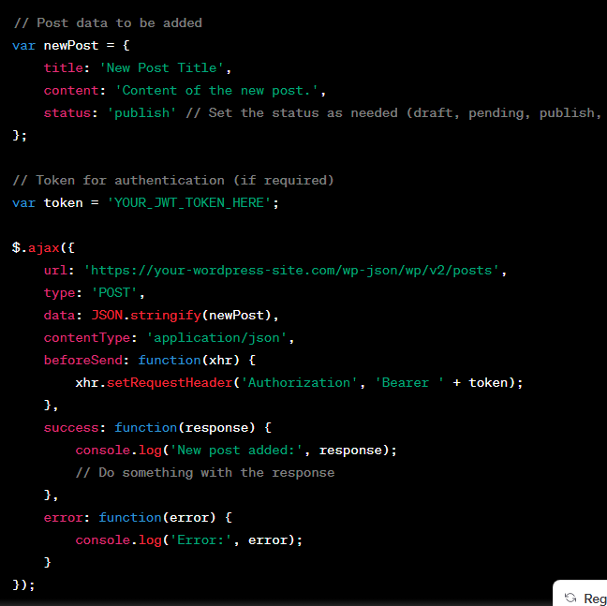

By wordpress

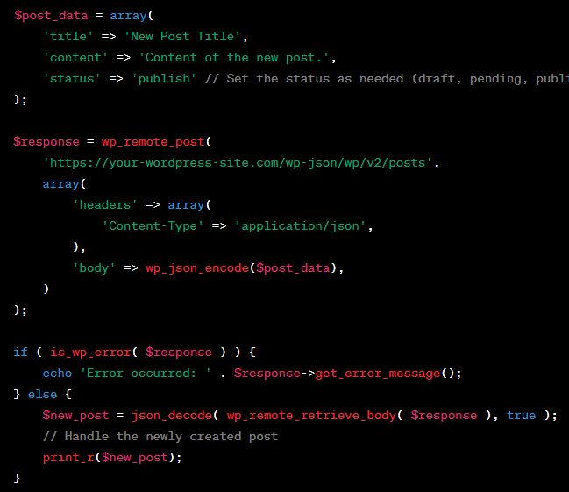

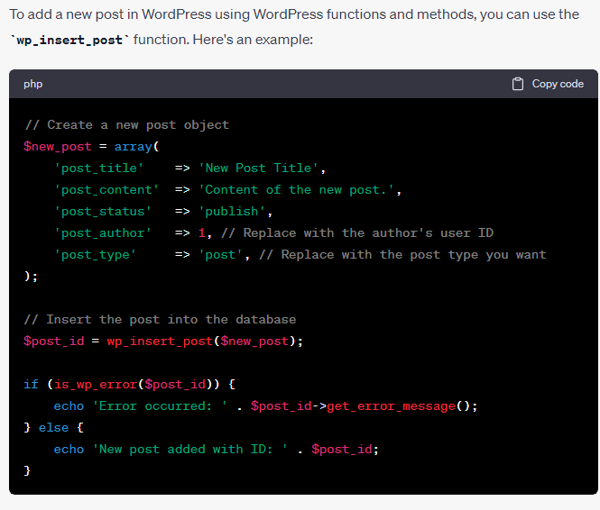

Another way

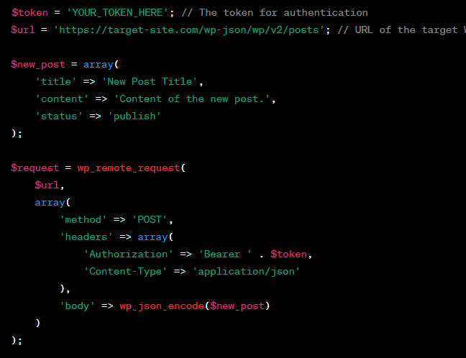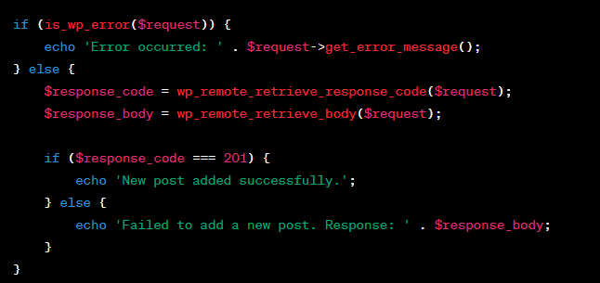

Another way

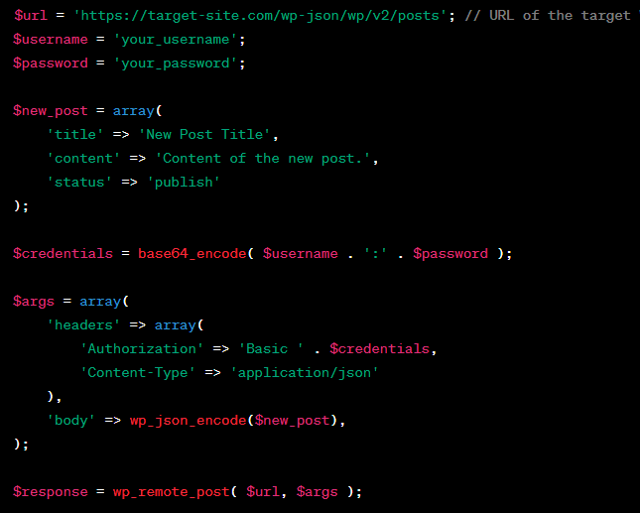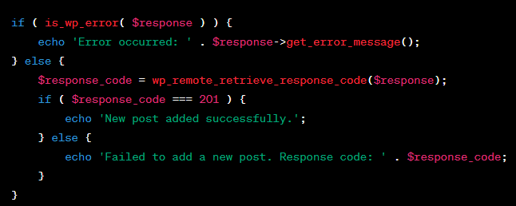

To delete a specific post in WordPress using the REST API

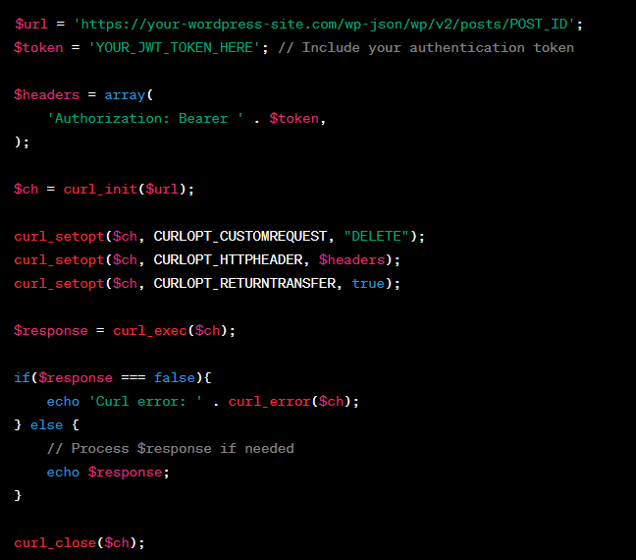

To delete specific post in wp by rest api by jquery ajax

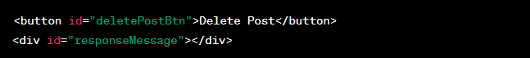

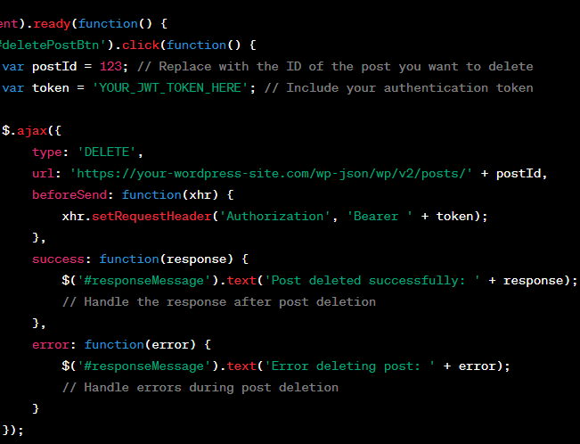

To update specific post in wp by rest api

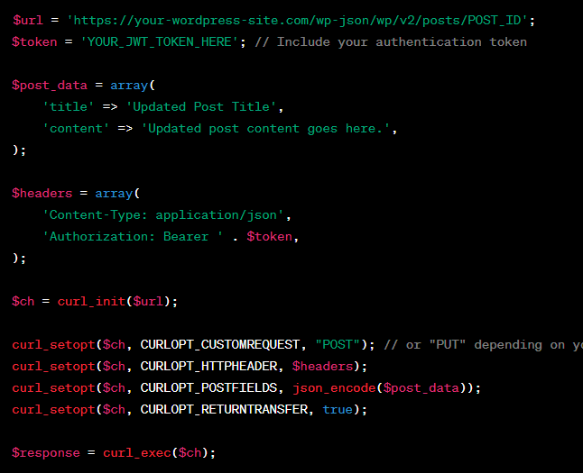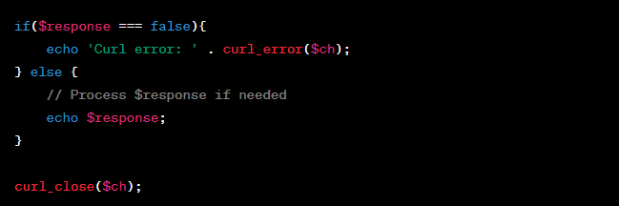

To update specific post in wp by rest api by jquery



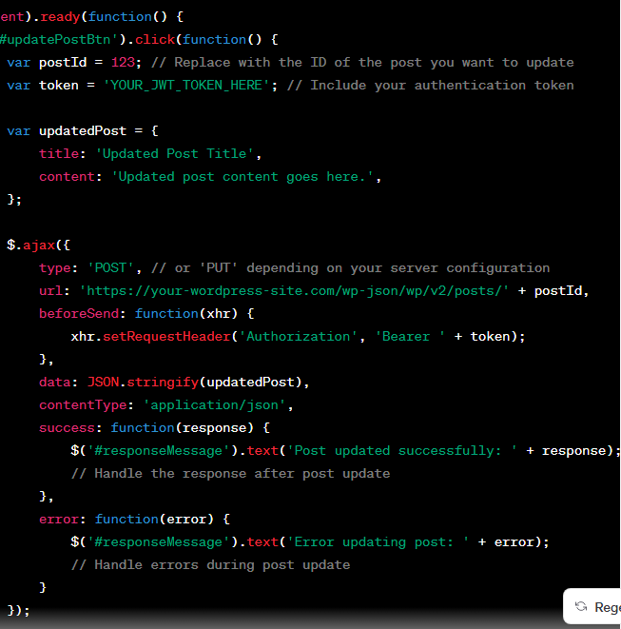

How to fetch all user of wordpress in through rest api by js

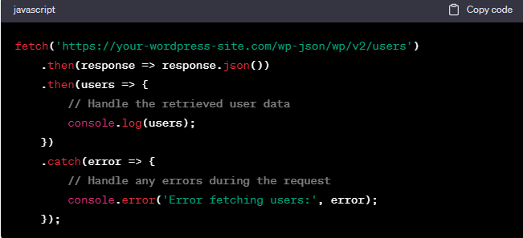

By Jquery

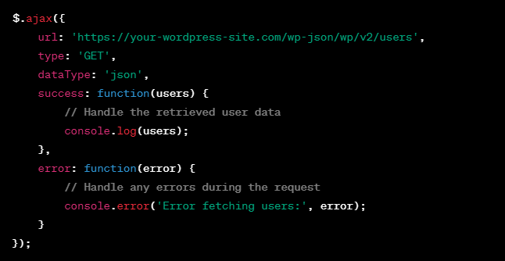

By php curl

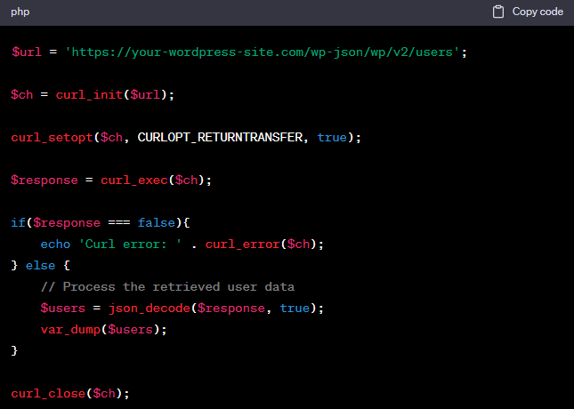

How to create user in wp through rest api by php curl

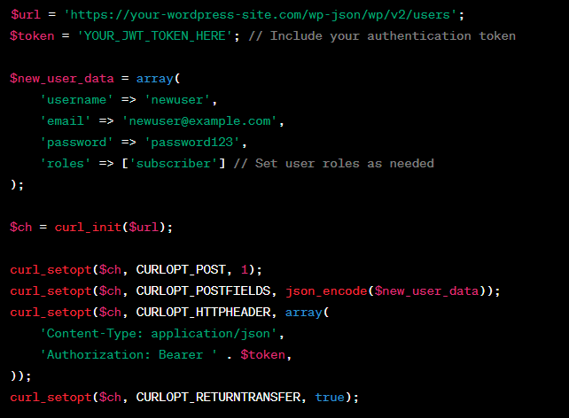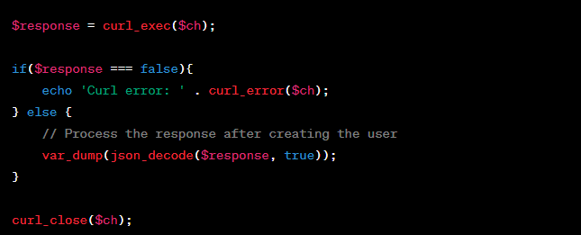

By Jquery



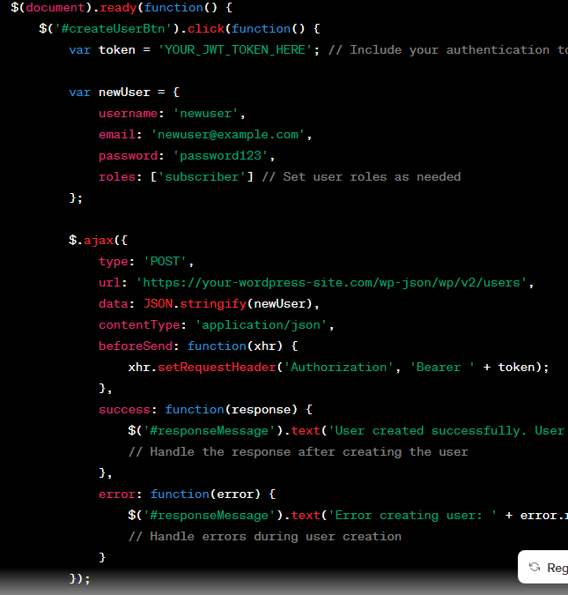



how to create Wordpress custom registration form

**Custom Registration Form HTML**:

<form id="custom-registration-form" action="<?php echo esc\_url( admin\_url('admin-post.php') ); ?>" method="post">

    <input type="text" name="username" placeholder="Username">

    <input type="email" name="email" placeholder="Email">

    <input type="password" name="password" placeholder="Password">

    <input type="text" name="mobile" placeholder="Mobile Number">

    <input type="text" name="address" placeholder="Address">

    <input type="date" name="dob" placeholder="Date of Birth">

    <input type="submit" name="submit" value="Register">

    <input type="hidden" name="action" value="custom\_register">

    <?php wp\_nonce\_field( 'custom-register-nonce', 'custom-register-nonce' ); ?>

</form>

**Form Processing in functions.php**:

function custom\_registration() {

    if (isset($\_POST['submit'])) {

        if( wp\_verify\_nonce( $\_POST['custom-register-nonce'], 'custom-register-nonce' ) ) {

            $username = sanitize\_user( $\_POST['username'] );

            $email = sanitize\_email( $\_POST['email'] );

            $password = $\_POST['password'];

            $mobile = sanitize\_text\_field( $\_POST['mobile'] );

            $address = sanitize\_text\_field( $\_POST['address'] );

            $dob = sanitize\_text\_field( $\_POST['dob'] );

            $userdata = array(

                'user\_login' => $username,

                'user\_email' => $email,

                'user\_pass' => $password,

                'user\_url' => $mobile, // Storing mobile number in the user's URL field

            );

            $user\_id = wp\_insert\_user( $userdata );

            if ( is\_wp\_error($user\_id) ) {

                echo $user\_id->get\_error\_message();

            } else {

                // Additional meta fields for user data

                update\_user\_meta($user\_id, 'user\_address', $address);

                update\_user\_meta($user\_id, 'user\_dob', $dob);

                echo 'Registration successful!';

            }

        }

    }

}

add\_action('admin\_post\_custom\_register', 'custom\_registration');

add\_action('admin\_post\_nopriv\_custom\_register', 'custom\_registration');

how to display custom this field on user profile page

// Function to add custom fields to user profile

function custom\_user\_profile\_fields($user) {

    ?>

    <h3>Custom Profile Fields</h3>

    <table class="form-table">

        <tr>

            <th><label for="mobile">Mobile Number</label></th>

            <td><input type="text" name="mobile" id="mobile" value="<?php echo esc\_attr(get\_the\_author\_meta('user\_url', $user->ID)); ?>" class="regular-text"></td>

        </tr>

        <tr>

            <th><label for="address">Address</label></th>

            <td><input type="text" name="address" id="address" value="<?php echo esc\_attr(get\_user\_meta($user->ID, 'user\_address', true)); ?>" class="regular-text"></td>

        </tr>

        <tr>

            <th><label for="dob">Date of Birth</label></th>

            <td><input type="date" name="dob" id="dob" value="<?php echo esc\_attr(get\_user\_meta($user->ID, 'user\_dob', true)); ?>" class="regular-text"></td>

        </tr>

    </table>

    <?php

}

add\_action('show\_user\_profile', 'custom\_user\_profile\_fields');

add\_action('edit\_user\_profile', 'custom\_user\_profile\_fields');

// Function to save custom fields on user profile update

function save\_custom\_user\_profile\_fields($user\_id) {

    if (!current\_user\_can('edit\_user', $user\_id)) {

        return false;

    }

    if (isset($\_POST['mobile'])) {

        update\_user\_meta($user\_id, 'user\_url', $\_POST['mobile']); // Save mobile to user\_url field

    }

    if (isset($\_POST['address'])) {

        update\_user\_meta($user\_id, 'user\_address', $\_POST['address']); // Save address to user meta

    }

    if (isset($\_POST['dob'])) {

        update\_user\_meta($user\_id, 'user\_dob', $\_POST['dob']); // Save date of birth to user meta

    }

}

add\_action('edit\_user\_profile\_update', 'save\_custom\_user\_profile\_fields');

**Jquery**

How to get field data from form by jquery

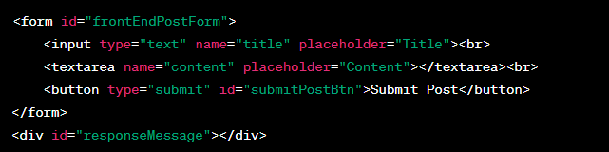

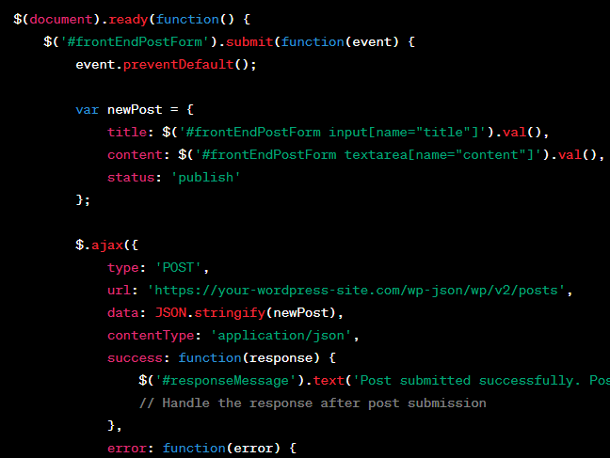

how to submit a form with field name, email, mobile, message through with submit button by jquery

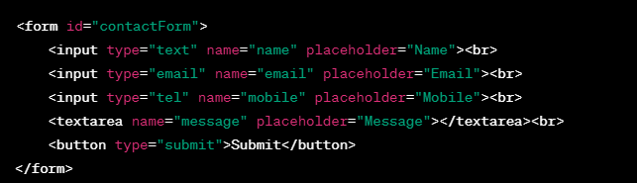 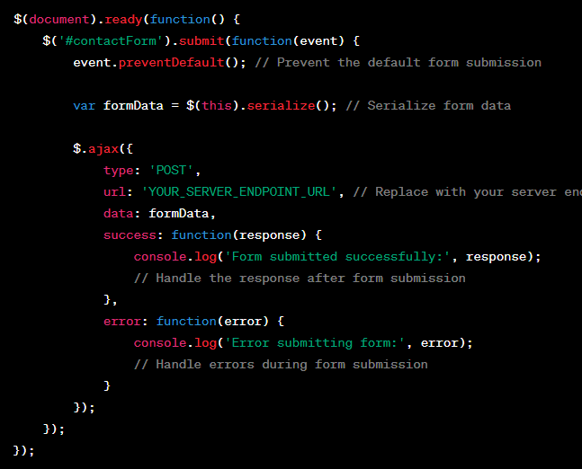

how to submit a form with field name, email, mobile, message through with submit button by jquery but without reloading page

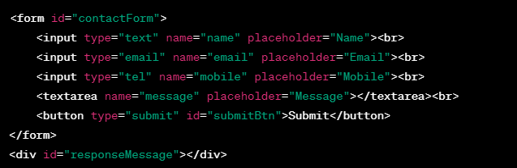 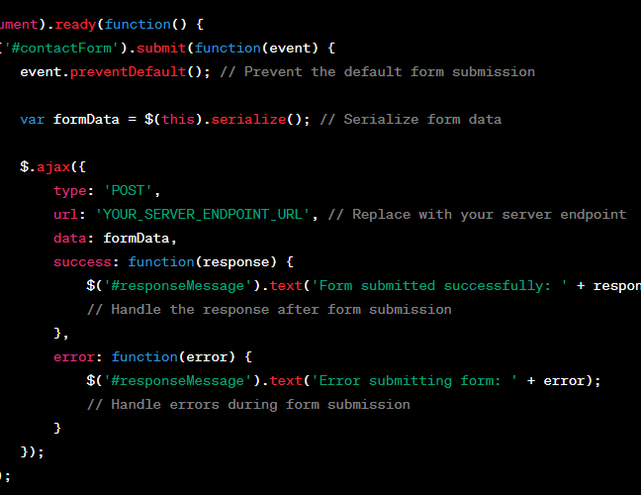

**Form validation**

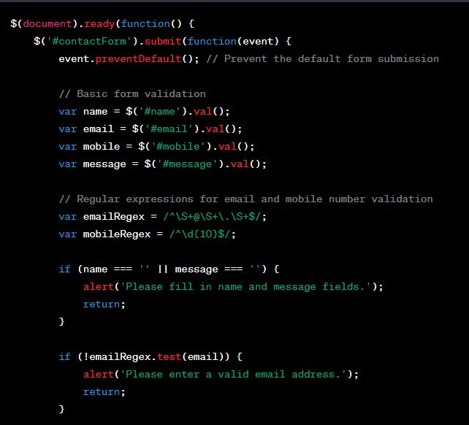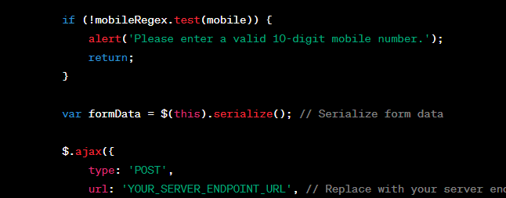

### Complete Rest API

### <https://tutorialsclass.com/php-rest-api-file_get_contents/>

### <https://dummy.restapiexample.com/>

### 

### 

### 

### 

### 

### 

### 

### 

### 

### 

### 

### 

**Disable WordPress REST API**

add\_filter( 'json\_enabled', '\_\_return\_false' ); add\_filter( 'json\_jsonp\_enabled', '\_\_return\_false' );

**Here's how to get and use REST API endpoints in WordPress**

In WordPress, you can access the REST API endpoints by default without any additional configuration. The REST API is enabled by default in recent WordPress versions, and it provides access to various data and functionalities within your WordPress site

**Explore Available Endpoints**: You can explore the available REST API endpoints by visiting the following URL in your browser

[**http://yourwordpresssite.com/wp-json/**](http://yourwordpresssite.com/wp-json/)

This will give you a list of available routes and endpoints. You can navigate through this structure to find the specific endpoint you want to use

**Retrieve Data from an Endpoint**

To retrieve data from a specific endpoint, you can use the wp\_remote\_get() function in WordPress. Here's an example of how to use it to retrieve data from the REST API

**// Define the API endpoint URL**

**$api\_url = 'http://yourwordpresssite.com/wp-json/wp/v2/posts';**

**// Make the API request**

**$response = wp\_remote\_get($api\_url);**

**// Check if the request was successful**

**if (is\_array($response) && !is\_wp\_error($response)) {**

**// Parse the JSON response**

**$data = json\_decode(wp\_remote\_retrieve\_body($response));**

**// Process and use the data as needed**

**foreach ($data as $post) {**

**echo 'Title: ' . $post->title->rendered . '<br>';**

**echo 'Content: ' . $post->content->rendered . '<br>';**

**}**

**}**

In the code above, we are making a GET request to the /wp-json/wp/v2/posts endpoint to retrieve a list of posts. You can replace this endpoint with the one you need.

**Authentication and Permissions:** Some REST API endpoints may require authentication or have different permission levels. You may need to provide authentication credentials or set up custom endpoints with specific permissions if necessary.

**Customizing and Extending Endpoints:** WordPress allows you to customize and extend REST API endpoints to suit your specific needs. You can create custom endpoints using the register\_rest\_route() function in your theme's functions.php file or a custom plugin. This allows you to define your own routes and callback functions for handling API requests.

Here's an example of registering a custom REST API endpoint:

**function custom\_api\_route() {**

**register\_rest\_route('custom/v1', 'my-endpoint', array(**

**'methods' => 'GET',**

**'callback' => 'my\_custom\_callback',**

**));**

**}**

**function my\_custom\_callback($data) {**

**// Your custom logic here**

**return array('message' => 'Custom API endpoint response');**

**}**

**add\_action('rest\_api\_init', 'custom\_api\_route');**

In this example, we've registered a custom endpoint at /wp-json/custom/v1/my-endpoint. When you make a GET request to this endpoint, it will trigger the my\_custom\_callback function and return a custom response.

**To call a REST API in WordPress,**

you can use the built-in functions and classes provided by WordPress. Here's a step-by-step guide on how to call a REST API in WordPress:

**1.Determine the API Endpoint:**

Identify the REST API endpoint you want to call. WordPress provides several REST API endpoints for different resources, such as posts, pages, users, and custom endpoints created by plugins or themes.

**2.Use the WP HTTP API:**

WordPress provides the WP HTTP API, which is a set of functions and classes for making HTTP requests. The WP HTTP API supports various HTTP methods like GET, POST, PUT, and DELETE.

Here's an example of how to make a GET request to a REST API endpoint using the WP HTTP API:

**// Make a GET request to the REST API endpoint**

**$response = wp\_remote\_get('https://example.com/wp-json/wp/v2/posts');**

**// Check if the request was successful**

**if (is\_wp\_error($response)) {**

**$error\_message = $response->get\_error\_message();**

**echo "Error: $error\_message";**

**} else {**

**$body = wp\_remote\_retrieve\_body($response);**

**$data = json\_decode($body, true);**

**// Process the response data**

**}**

**Process the response data**

**}**

**What is localize script in ajax of wordpress**

In WordPress, **wp\_localize\_script** is a function used to make data from the server-side (PHP) available for use in client-side (JavaScript) scripts. It's a powerful tool for passing dynamic data, such as configuration settings or localized strings, from your WordPress server to your JavaScript code, including those used in Ajax requests.

Here's how **wp\_localize\_script** works in the context of Ajax in WordPress:

**Enqueue Your JavaScript File:**

First, you enqueue your JavaScript file using the **wp\_enqueue\_script** function. This ensures that your JavaScript file is loaded on the page where you want to use it.

**wp\_enqueue\_script('your-script-handle', 'path-to-your-script.js', array('jquery'), '1.0', true);**

**Use wp\_localize\_script:**

Next, you use the **wp\_localize\_script** function to pass data from the server to your JavaScript file. This function takes the following parameters:

* + Script handle: The handle of the JavaScript file you want to localize.
  + Object name: The name of the JavaScript object that will hold the localized data.
  + Data array: An array of key-value pairs containing the data you want to pass.

**wp\_localize\_script('your-script-handle', 'yourLocalizedData', array(**

**'ajax\_url' => admin\_url('admin-ajax.php'),**

**'nonce' => wp\_create\_nonce('your-nonce'),**

**// Other data...**

**));**

**Access Data in JavaScript:**

In your JavaScript file, you can access the localized data through the **yourLocalizedData** object. For example:

**// Access the Ajax URL**

**var ajaxUrl = yourLocalizedData.ajax\_url;**

**// Access the nonce**

**var nonce = yourLocalizedData.nonce;**

**Use the Data in Ajax Requests:**

When making Ajax requests in your JavaScript code, you can use the **ajaxUrl** and **nonce** variables to specify the Ajax URL and add security checks to your requests. For example:

**jQuery.ajax({**

**type: 'POST',**

**url: ajaxUrl,**

**data: {**

**action: 'your\_ajax\_action',**

**nonce: nonce,**

**// Other data...**

**},**

**success: function(response) {**

**// Handle the response**

**}**

**});**

In this code, 'your\_ajax\_action' should be replaced with the name of the server-side action that handles your Ajax request.

By localizing scripts using wp\_localize\_script, you can keep your JavaScript code modular and organized while still having access to dynamic server-side data. This is particularly useful when working with Ajax in WordPress, as it allows you to pass essential data, such as security tokens or URLs, seamlessly from the server to the client.

**// Define a custom shortcode to display the current date**

**function custom\_current\_date\_shortcode() {**

**$current\_date = date('Y-m-d');**

**return "Today's date is: $current\_date";**

**}**

**add\_shortcode('current\_date', 'custom\_current\_date\_shortcode');**

**Load more post by AJAX Call**

**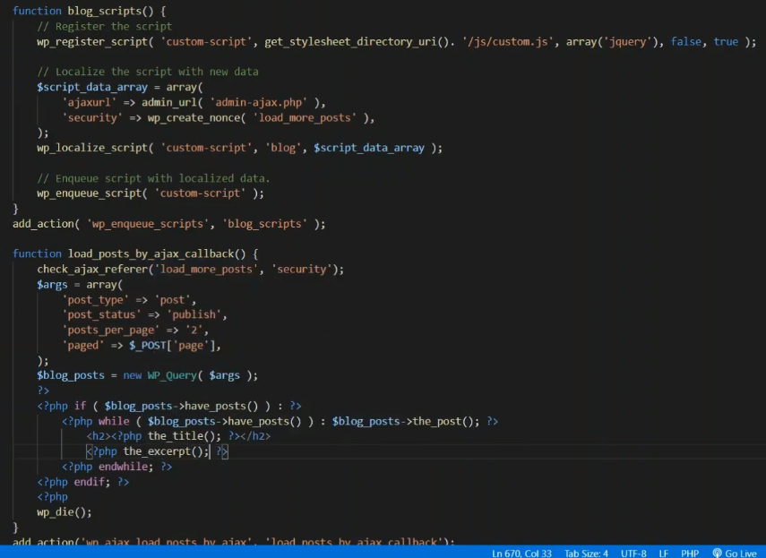**

**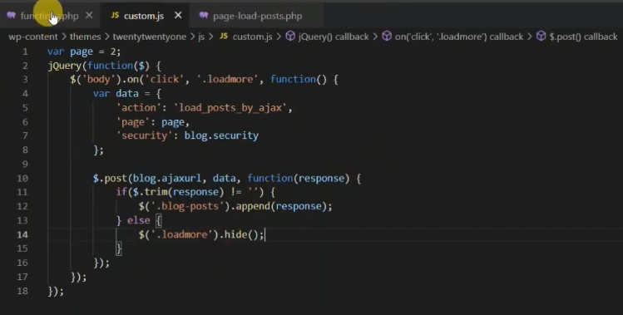**

**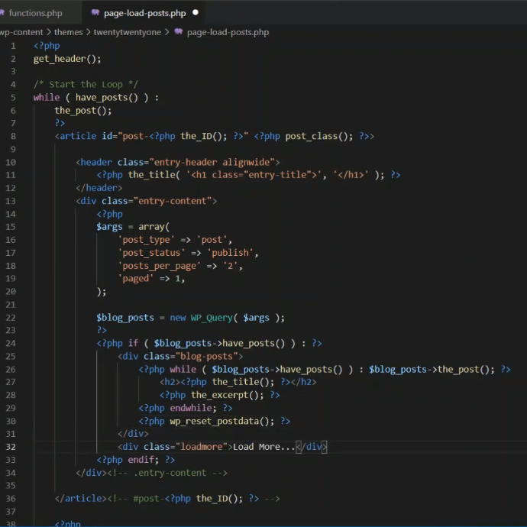**

**Reffrence link** [**https://www.youtube.com/watch?v=2k-hPpHzL1Q&t=28**](https://www.youtube.com/watch?v=2k-hPpHzL1Q&t=28)

[**https://artisansweb.net/load-wordpress-post-ajax/**](https://artisansweb.net/load-wordpress-post-ajax/)

[**https://www.youtube.com/watch?v=bBsIHE-lkGo&list=PLaoZUFJYLaOYRd\_WSV22NPv7q-ZV4gKWs&index=78**](https://www.youtube.com/watch?v=bBsIHE-lkGo&list=PLaoZUFJYLaOYRd_WSV22NPv7q-ZV4gKWs&index=78)

**Block development link**

**AJAX call in WordPress, you can follow these steps:**

**Reference**

[**https://developer.wordpress.org/plugins/javascript/ajax/**](https://developer.wordpress.org/plugins/javascript/ajax/)

**1.Enqueue jQuery:**

**function enqueue\_scripts() {**

**wp\_enqueue\_script('jquery');**

**}**

**add\_action('wp\_enqueue\_scripts', 'enqueue\_scripts');**

**2.Create the JavaScript file:**

Create a new JavaScript file where you'll write the AJAX code. You can create a separate file or include it in an existing JavaScript file in your theme or plugin**.**

**For example, let's create a file called ajax-script.js:**

**jQuery(document).ready(function($) {**

**$.ajax({**

**url: ajax\_object.ajax\_url, // AJAX handler URL provided by WordPress**

**type: 'POST',**

**data: {**

**action: 'my\_ajax\_action',**

**// The PHP function to handle the AJAX request**

**// Add any additional data you want to send to the server**

**},**

**success: function(response) {**

**},**

**error: function(xhr, status, error) {**

**// Handle AJAX error**

**}**

**});**

**});**

**3.Register the AJAX handler in PHP:**

In your theme or plugin's functions.php file, register a PHP function to handle the AJAX request.

**function my\_ajax\_handler() {**

**// Handle the AJAX request**

**// Perform any necessary processing or database operations**

**// Generate the response data**

**// Send the response**

**wp\_send\_json($response);**

**}**

**add\_action('wp\_ajax\_my\_ajax\_action', 'my\_ajax\_handler');**

**add\_action('wp\_ajax\_nopriv\_my\_ajax\_action', 'my\_ajax\_handler'); // For non-logged-in users**

Make sure to replace 'my\_ajax\_action' with the name you provided in the AJAX call (step 2).

**4.Localize the JavaScript file:**

In your theme or plugin's functions.php file, use the wp\_localize\_script() function to pass the AJAX handler URL to the JavaScript file. Add the following code:

**function localize\_scripts()**

**{**

**wp\_enqueue\_script('ajax-script', get\_template\_directory\_uri() . '/path/to/ajax-script.js', array('jquery'), '1.0', true);**

**wp\_localize\_script('ajax-script', 'ajax\_object', array('ajax\_url' => admin\_url('admin-ajax.php')));**

**}**

**add\_action('wp\_enqueue\_scripts', 'localize\_scripts');**

**Make sure to replace '/path/to/ajax-script.js' with the correct path to your JavaScript file.**

That's it! You now have an AJAX call set up in WordPress. When the JavaScript code is executed, it will send an AJAX request to the server, which will be handled by the PHP function specified in the AJAX action. You can perform any necessary processing, database operations, and generate a response that will be sent back to the JavaScript code for further handling.

**Wordpress Ajax Call**

**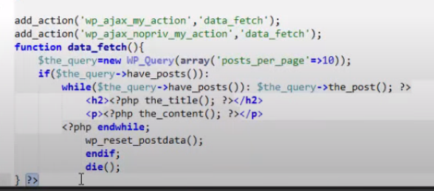**

**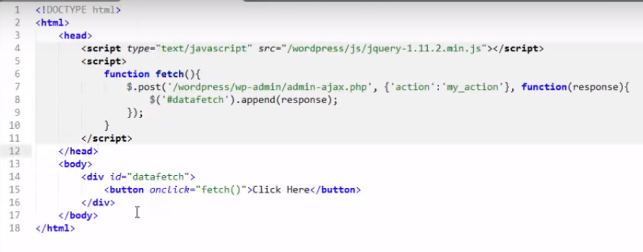**

**WP Ajax call Visshal programming**

**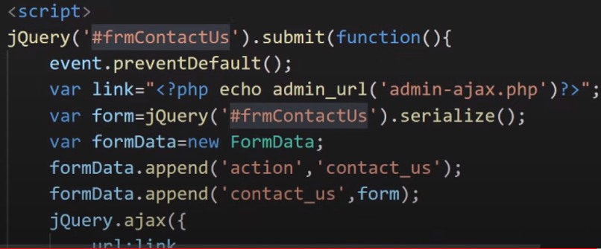**

**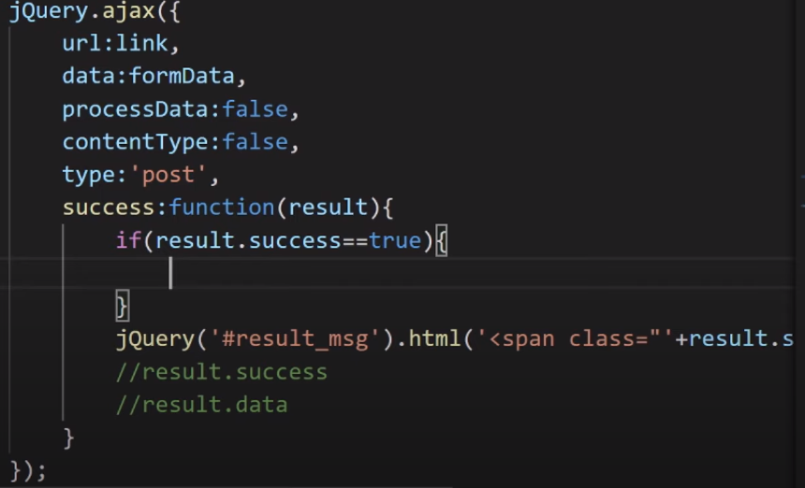**

**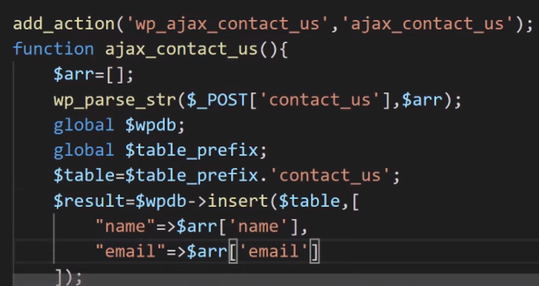**

**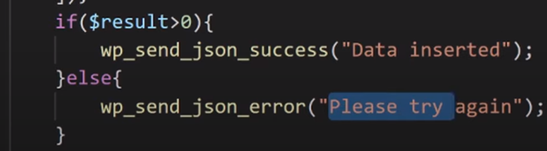**

**Load more post by AJAX Call**

****

****

****

**Reffrence link** [**https://www.youtube.com/watch?v=2k-hPpHzL1Q&t=28**](https://www.youtube.com/watch?v=2k-hPpHzL1Q&t=28)

[**https://artisansweb.net/load-wordpress-post-ajax/**](https://artisansweb.net/load-wordpress-post-ajax/)

[**https://www.youtube.com/watch?v=bBsIHE-lkGo&list=PLaoZUFJYLaOYRd\_WSV22NPv7q-ZV4gKWs&index=78**](https://www.youtube.com/watch?v=bBsIHE-lkGo&list=PLaoZUFJYLaOYRd_WSV22NPv7q-ZV4gKWs&index=78)

**Ajax call**

[**https://developer.wordpress.org/plugins/javascript/ajax/**](https://developer.wordpress.org/plugins/javascript/ajax/)

#### [Client Side Summary](https://developer.wordpress.org/plugins/javascript/ajax/#client-side-summary)

Now that we’ve added our callback as the final parameter for the $.post() function, we’ve completed our sample jQuery Ajax script. All the pieces put together look like this:

**jQuery(document).ready(function($) {         //wrapper**

**$(".pref").change(function() {          //event**

**var this2 = this;                  //use in callback**

**$.post(my\_ajax\_obj.ajax\_url, {      //POST request**

**\_ajax\_nonce: my\_ajax\_obj.nonce, //nonce**

**action: "my\_tag\_count",         //action**

**title: this.value               //data**

**}, function(data) {            //callback**

**this2.nextSibling.remove(); //remove current title**

**$(this2).after(data);       //insert server response**

**}**

**);**

**} );**

**} );**

**$title\_nonce = wp\_create\_nonce( 'title\_example' );**

**wp\_localize\_script(**

**'ajax-script',**

**'my\_ajax\_obj',**

**array(**

**'ajax\_url' => admin\_url( 'admin-ajax.php' ),**

**'nonce'    => $title\_nonce,**

**)**

**);**

**Sample code**

**add\_action( 'admin\_enqueue\_scripts', 'my\_enqueue' );**

**/\*\***

**\* Enqueue my scripts and assets.**

**\***

**\* @param $hook**

**\*/**

**function my\_enqueue( $hook ) {**

**if ( 'myplugin\_settings.php' !== $hook ) {**

**return;**

**}**

**wp\_enqueue\_script(**

**'ajax-script',**

**plugins\_url( '/js/myjquery.js', \_\_FILE\_\_ ),**

**array( 'jquery' ),**

**'1.0.0',**

**true**

**);**

**wp\_localize\_script(**

**'ajax-script',**

**'my\_ajax\_obj',**

**array(**

**'ajax\_url' => admin\_url( 'admin-ajax.php' ),**

**'nonce'    => wp\_create\_nonce( 'title\_example' ),**

**)**

**);**

**}**

#### [Register vs. Enqueue](https://developer.wordpress.org/plugins/javascript/enqueuing/#register-vs-enqueue)

You will see examples in other tutorials that religiously use [wp\_register\_script()](https://developer.wordpress.org/reference/functions/wp_register_script/). This is fine, but its use is optional. What is not optional is wp\_enqueue\_script(). This function must be called in order for your script file to be properly linked on the web page. So why register scripts? It creates a useful tag or handle with which you can easily reference the script in various parts of your code as needed. If you just need your script loaded and are not referencing it elsewhere in your code, there is no need to register it.

### [AJAX Handler Summary](https://developer.wordpress.org/plugins/javascript/enqueuing/#ajax-handler-summary)

### <https://developer.wordpress.org/plugins/javascript/enqueuing/>

**/\*\***

**\* AJAX handler using JSON**

**\*/**

**function my\_ajax\_handler\_\_json() {**

**check\_ajax\_referer( 'title\_example' );**

**$title = wp\_unslash( $\_POST['title'] );**

**update\_user\_meta( get\_current\_user\_id(), 'title\_preference', sanitize\_post\_title( $title ) );**

**$args      = array(**

**'tag' => $title,**

**);**

**$the\_query = new WP\_Query( $args );**

**wp\_send\_json( esc\_html( $title ) . ' (' . $the\_query->post\_count . ') ' );**

**}**

# Heartbeat API

## [How it works](https://developer.wordpress.org/plugins/javascript/heartbeat-api/#how-it-works)

When the page loads, the client-side heartbeat code sets up an interval (called the “tick”) to run every 15-120 seconds. When it runs, heartbeat gathers data to send via a jQuery event, then sends this to the server and waits for a response. On the server, an admin-ajax handler takes the passed data, prepares a response, filters the response, then returns the data in JSON format. The client receives this data and fires a final jQuery event to indicate the data has been received.

The basic process for custom Heartbeat events is:

1. Add additional fields to the data to be sent (JS heartbeat-send event)
2. Detect sent fields in PHP, and add additional response fields (heartbeat\_received filter)
3. Process returned data in JS (JS heartbeat-tick)

(You can choose to use only one or two of these events, depending on what functionality you need.)

## [Using the API](https://developer.wordpress.org/plugins/javascript/heartbeat-api/#using-the-api)

Using the heartbeat API requires two separate pieces of functionality: send and receive callbacks in JavaScript, and a server-side filter to process passed data in PHP.

### [Sending Data to the Server](https://developer.wordpress.org/plugins/javascript/heartbeat-api/#sending-data-to-the-server)

When Heartbeat sends data to the server, you can include custom data. This can be any data you want to send to the server, or a simple true value to indicate you are expecting data.

**jQuery( document ).on( 'heartbeat-send', function ( event, data ) {**

**// Add additional data to Heartbeat data.**

**data.myplugin\_customfield = 'some\_data';**

**});**

### [Receiving and Responding on the Server](https://developer.wordpress.org/plugins/javascript/heartbeat-api/#receiving-and-responding-on-the-server)

On the server side, you can then detect this data, and add additional data to the response.

/\*\*

 \* Receive Heartbeat data and respond.

 \*

 \* Processes data received via a Heartbeat request, and returns additional data to pass back to the front end.

 \*

 \* @param array $response Heartbeat response data to pass back to front end.

 \* @param array $data     Data received from the front end (unslashed).

 \*

 \* @return array

 \*/

function myplugin\_receive\_heartbeat( array $response, array $data ) {

    // If we didn't receive our data, don't send any back.

    if ( empty( $data['myplugin\_customfield'] ) ) {

        return $response;

    }

    // Calculate our data and pass it back. For this example, we'll hash it.

    $received\_data = $data['myplugin\_customfield'];

    $response['myplugin\_customfield\_hashed'] = sha1( $received\_data );

    return $response;

}

add\_filter( 'heartbeat\_received', 'myplugin\_receive\_heartbeat', 10, 2 );

### [Processing the Response](https://developer.wordpress.org/plugins/javascript/heartbeat-api/#processing-the-response)

Back on the frontend, you can then handle receiving this data back.

**jQuery( document ).on( 'heartbeat-tick', function ( event, data ) {**

**// Check for our data, and use it.**

**if ( ! data.myplugin\_customfield\_hashed ) {**

**return;**

**}**

**alert( 'The hash is ' + data.myplugin\_customfield\_hashed );**

**});**

**Ajax Calling Method**

**Method :1**

**<head>**

**<script src="https://ajax.googleapis.com/ajax/libs/jquery/3.6.4/jquery.min.js"></script>**

**<script>**

**$(document).ready(function(){**

**$("button").click(function(){**

**$("#div1").load("demo\_test.txt");**

**});**

**});**

**</script>**

**</head>**

**<body>**

**<div id="div1"><h2>Let jQuery AJAX Change This Text</h2></div>**

**<button>Get External Content</button>**

**</body>**

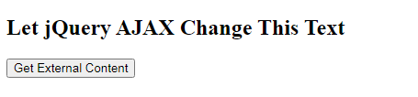

**After clicking result**

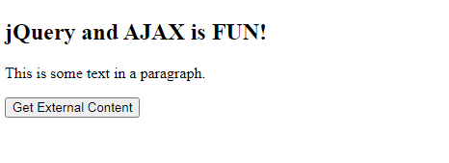

**Method :2**

**<head>**

**<script src="https://ajax.googleapis.com/ajax/libs/jquery/3.6.4/jquery.min.js"></script>**

**<script>**

**$(document).ready(function(){**

**$("button").click(function(){**

**$.ajax({url: "demo\_test.txt", success: function(result){**

**$("#div1").html(result);**

**}});**

**});**

**});**

**</script>**

**</head>**

**<body>**

**<div id="div1"><h2>Let jQuery AJAX Change This Text</h2></div>**

**<button>Get External Content</button>**

**</body>**

**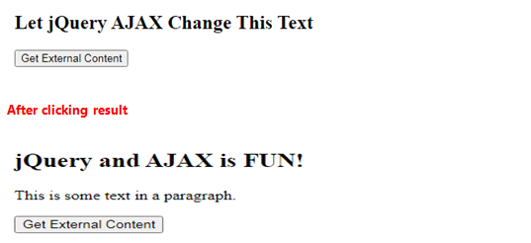**

**Method :3**

**<head>**

**<script src="https://ajax.googleapis.com/ajax/libs/jquery/3.6.4/jquery.min.js"></script>**

**<script>**

**$(document).ready(function(){**

**$("button").click(function(){**

**$.get("demo\_test.asp", function(data, status){**

**alert("Data: " + data + "\nStatus: " + status);**

**});**

**});**

**});**

**</script>**

**</head>**

**<body>**

**<button>Send an HTTP GET request to a page and get the result back</button>**

**</body>**

****

**Result**

**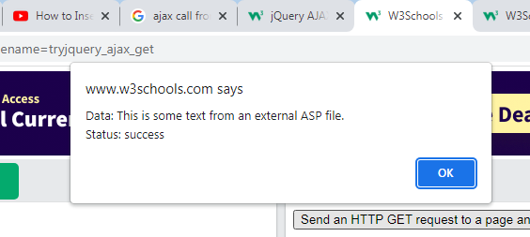**

**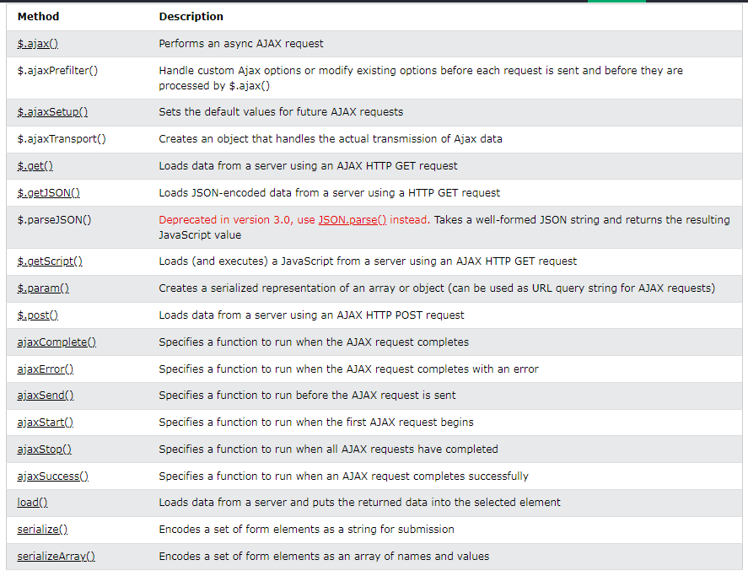**

**Ajax with PHP**

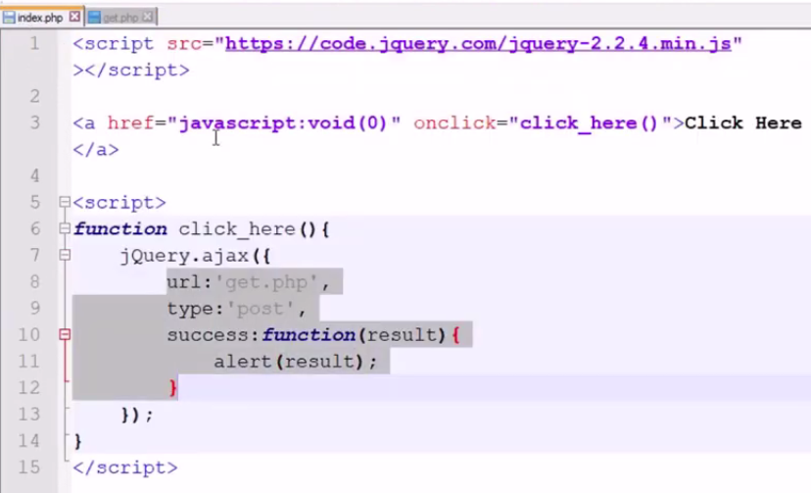

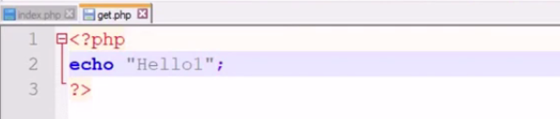

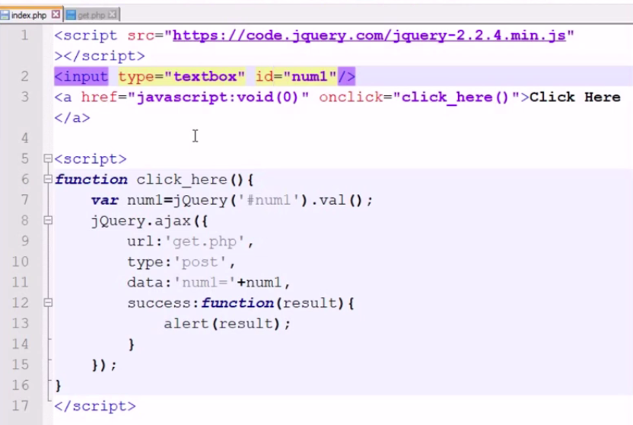

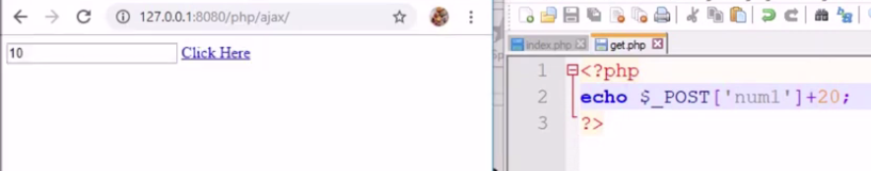

**Syncronus AJAX- Parallel, it is not waiting for other**

**Asyncronus AJAX it is depending on other, Its work one after one.**

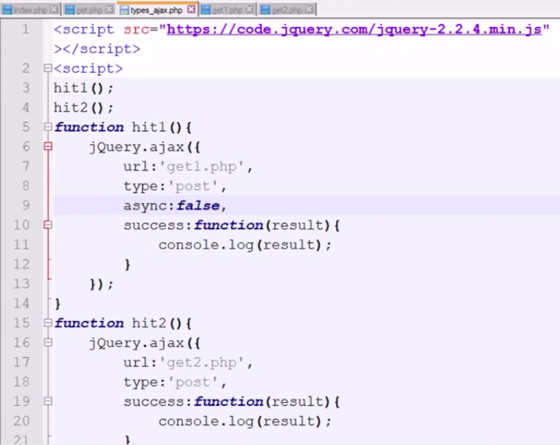

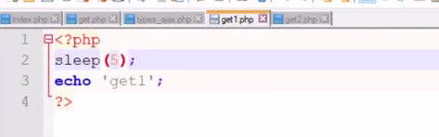

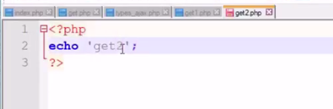

**AJAX With JSON Dataserve API call**

**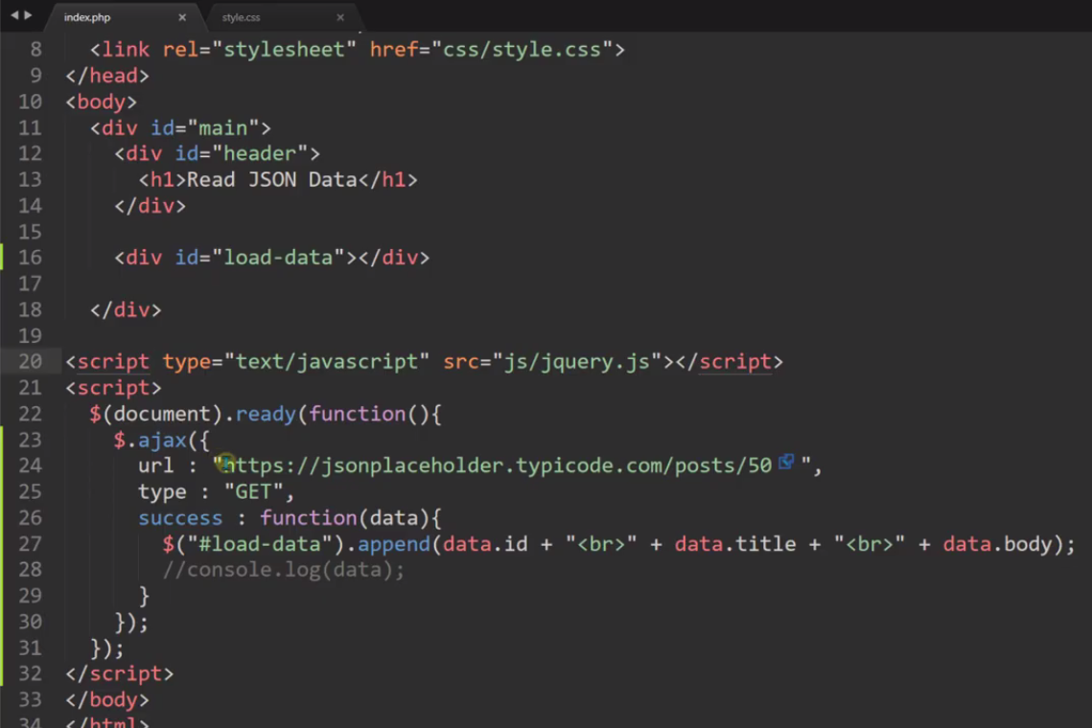**

**For looping data**

**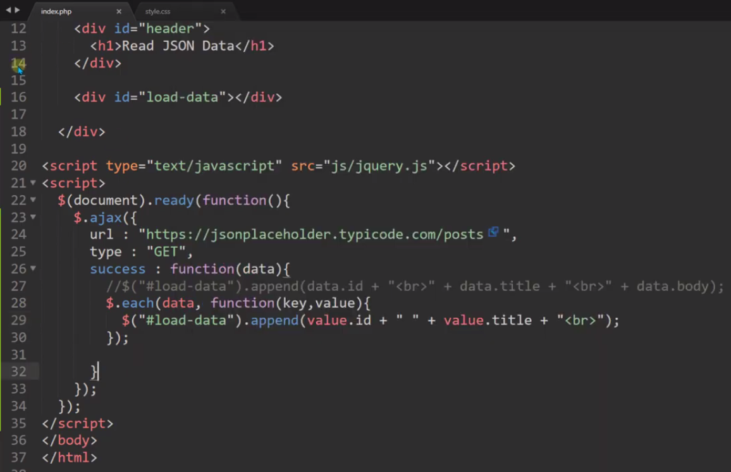**

**API call from Json file**

**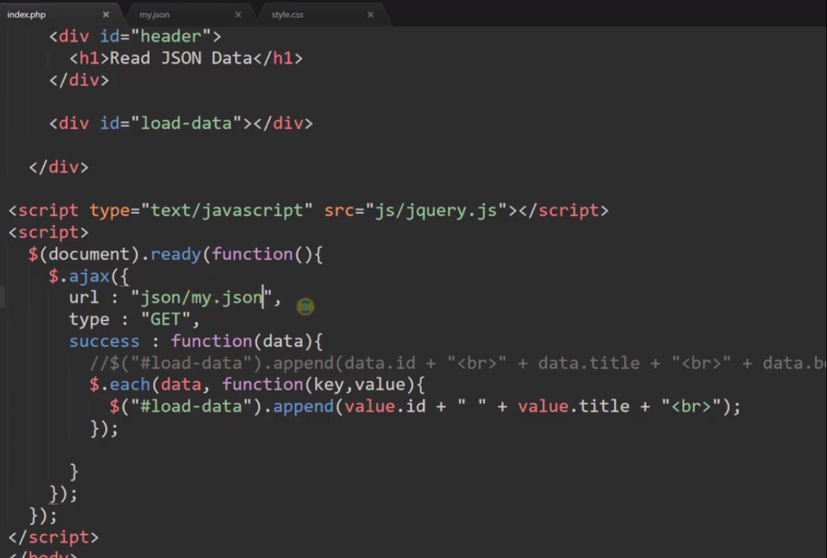**

**Sorcut method for AJAX call for Only JSON Data**

**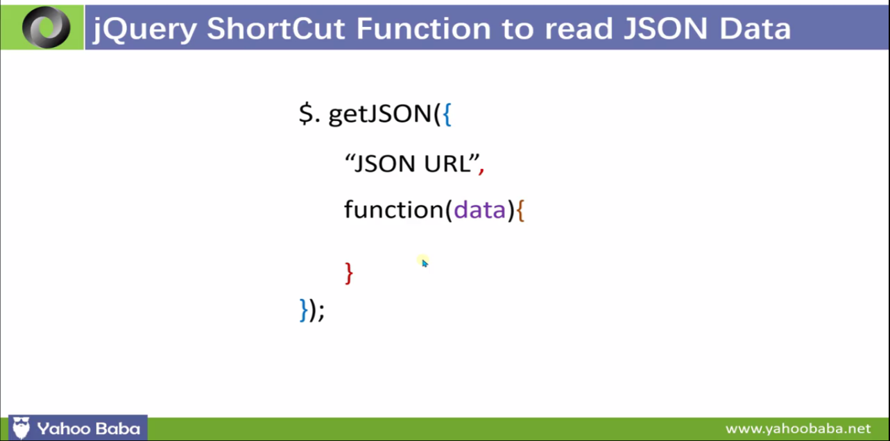**

**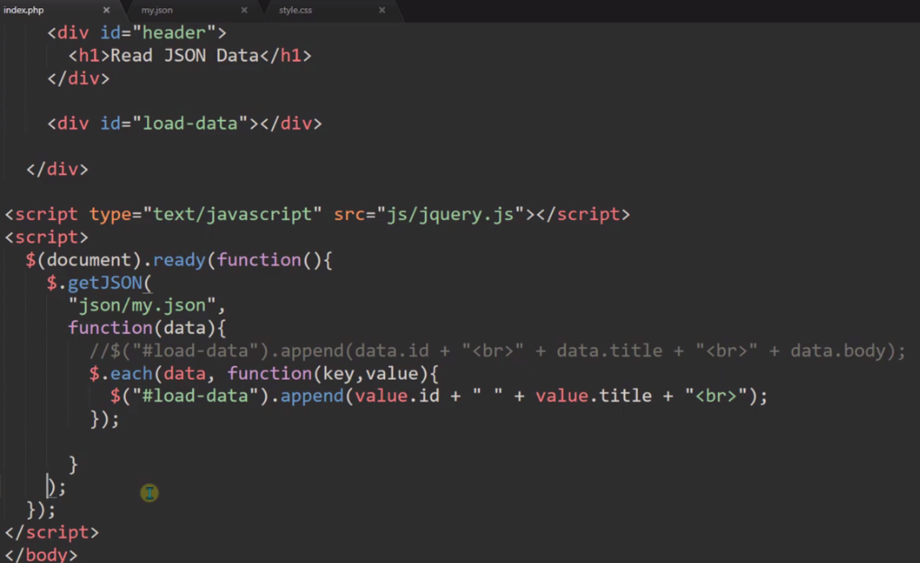**

**Ajax call**

**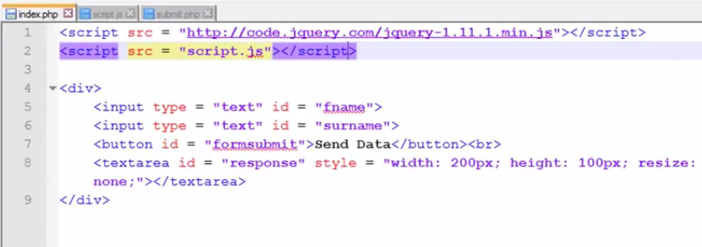**

**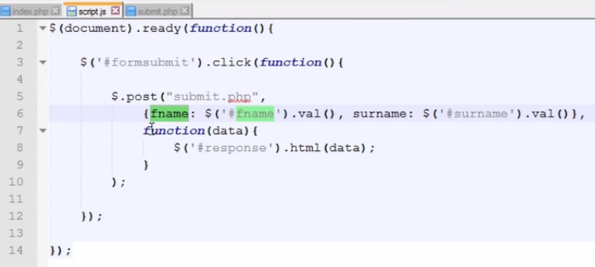**

**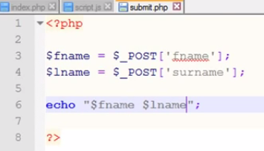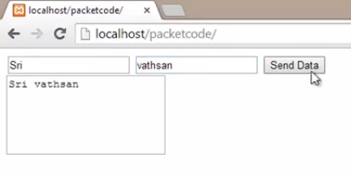**

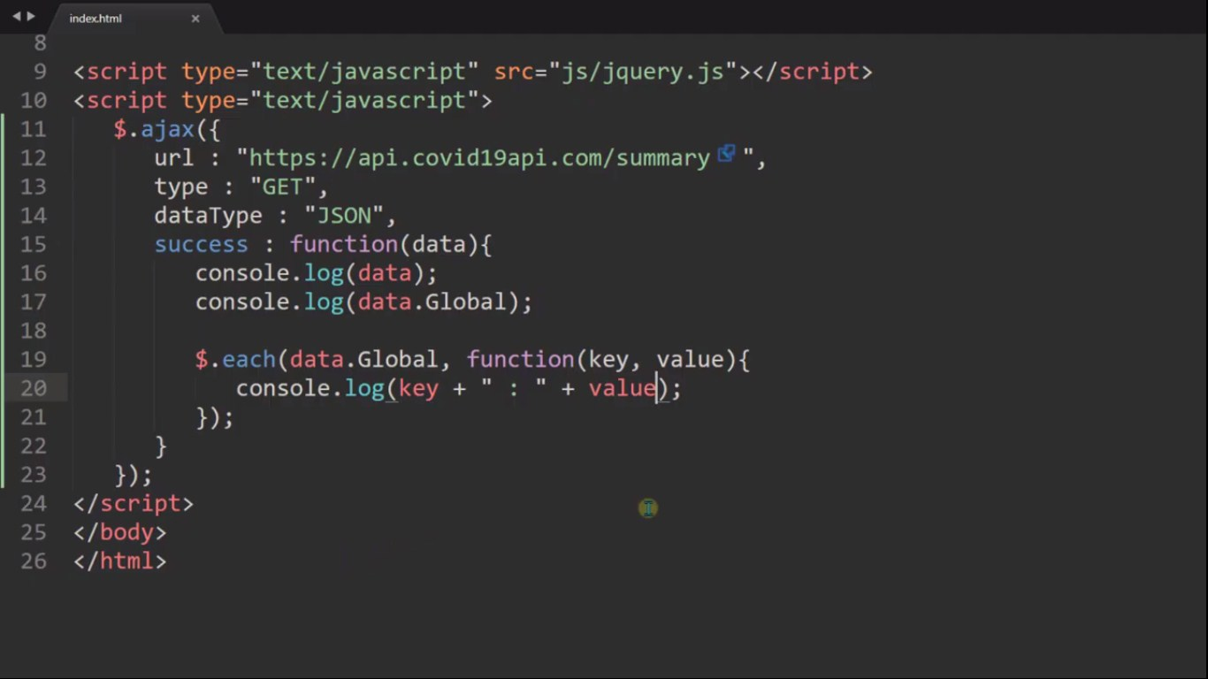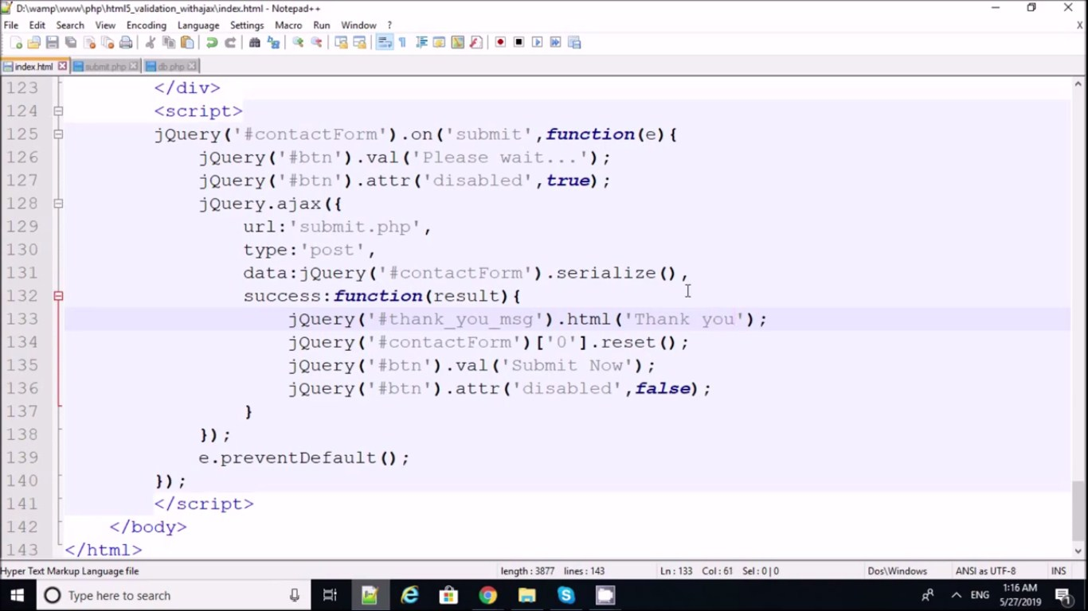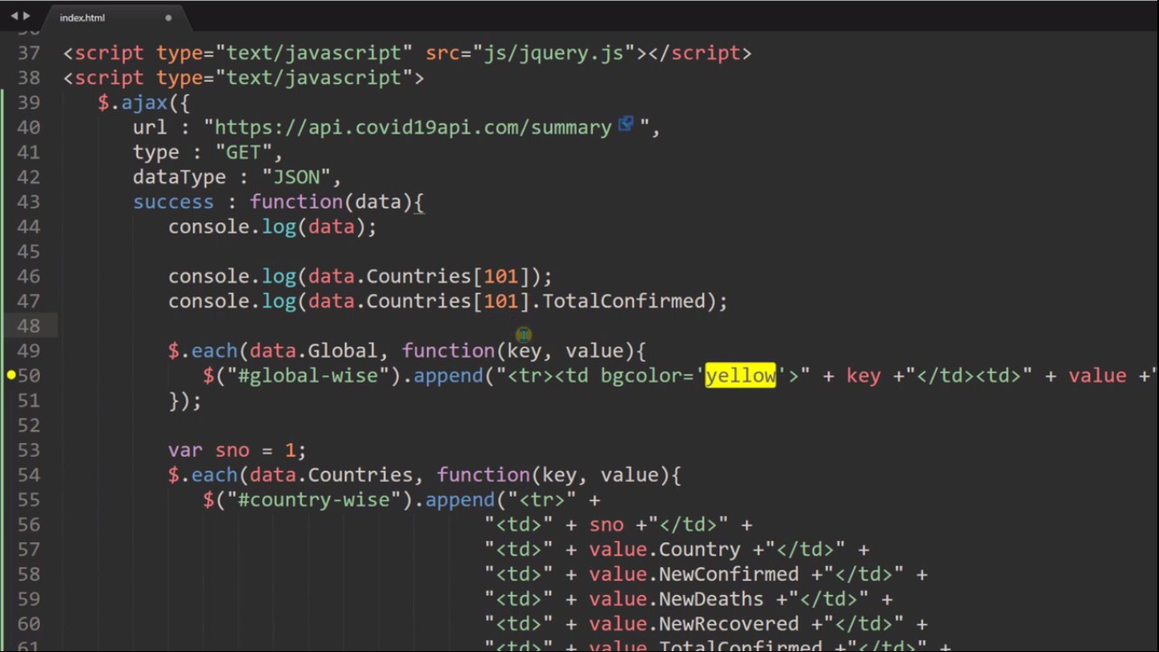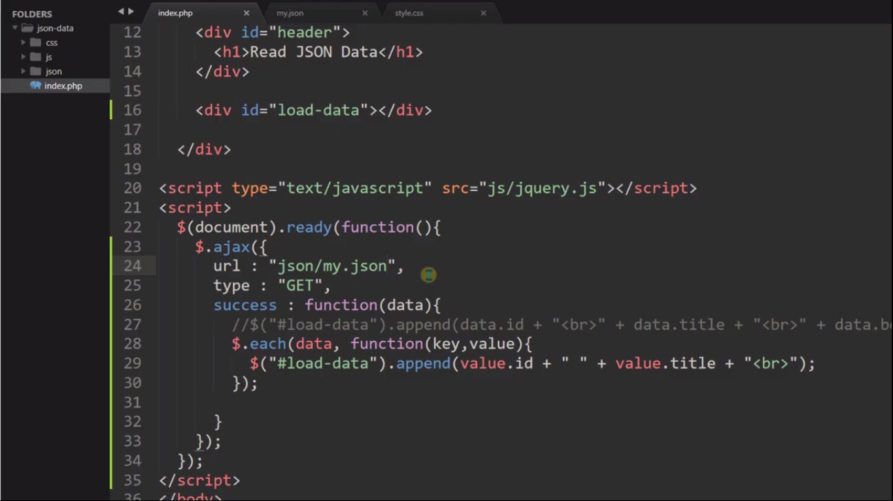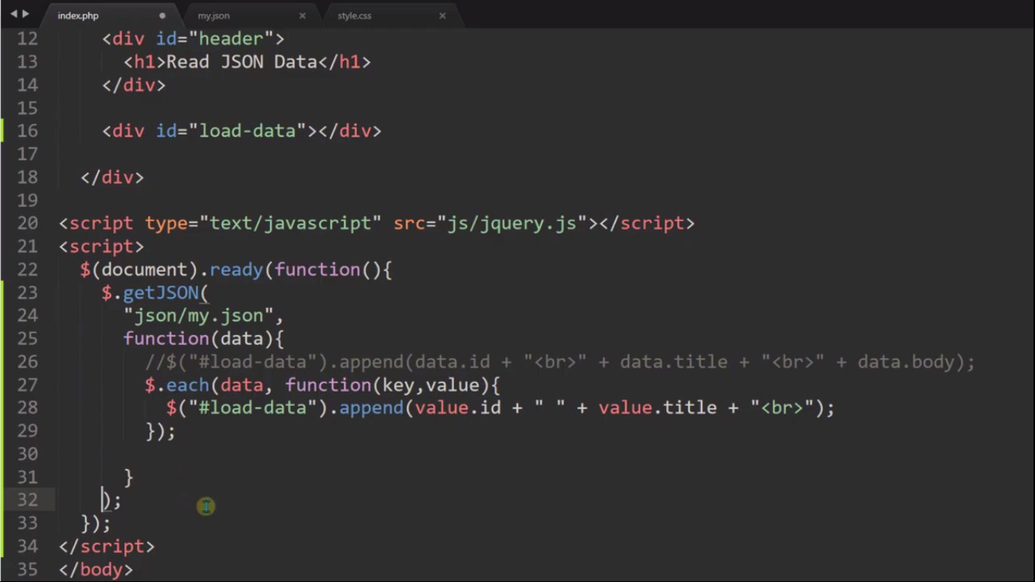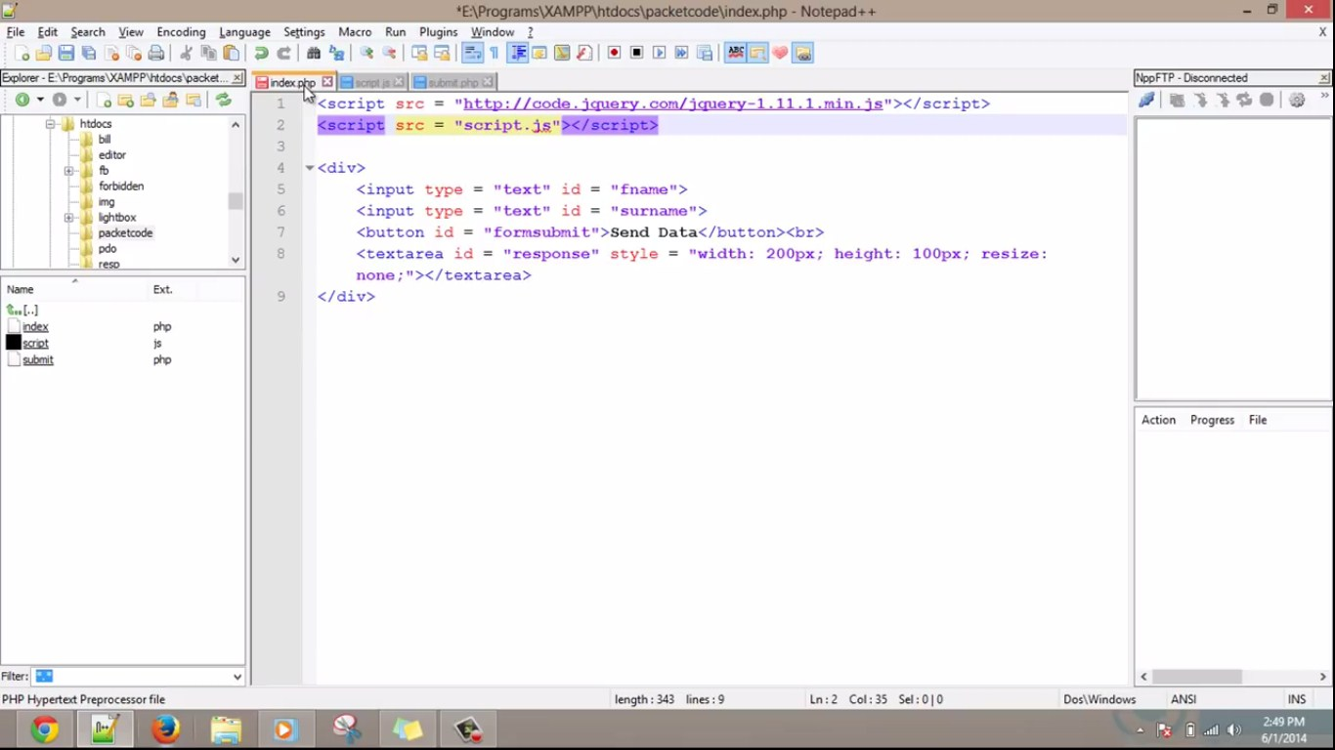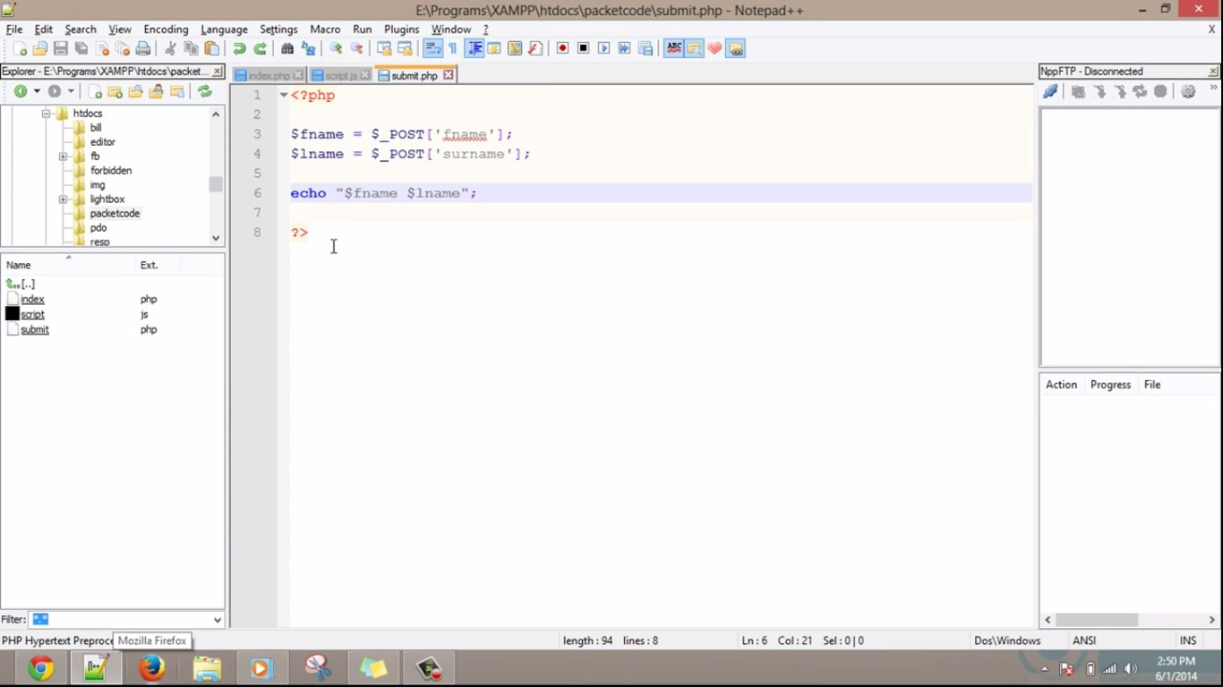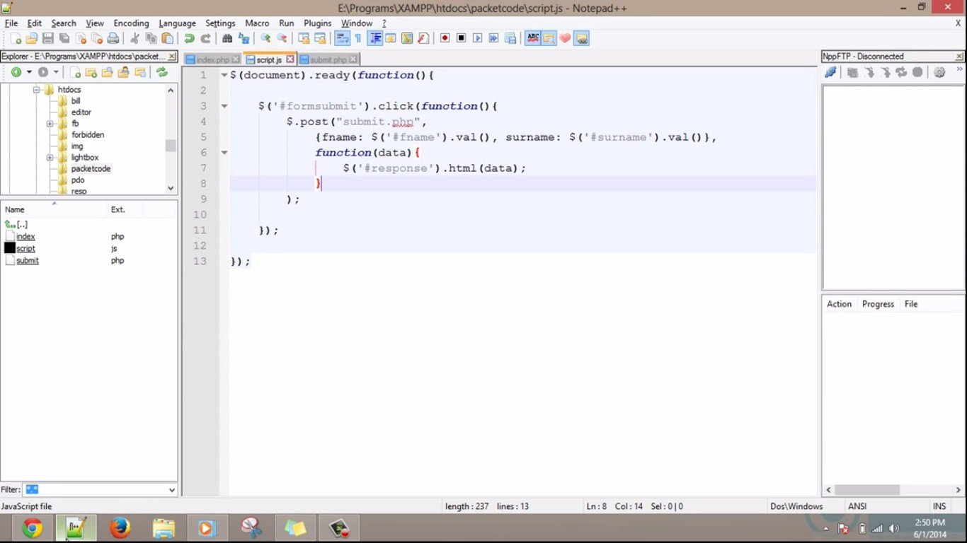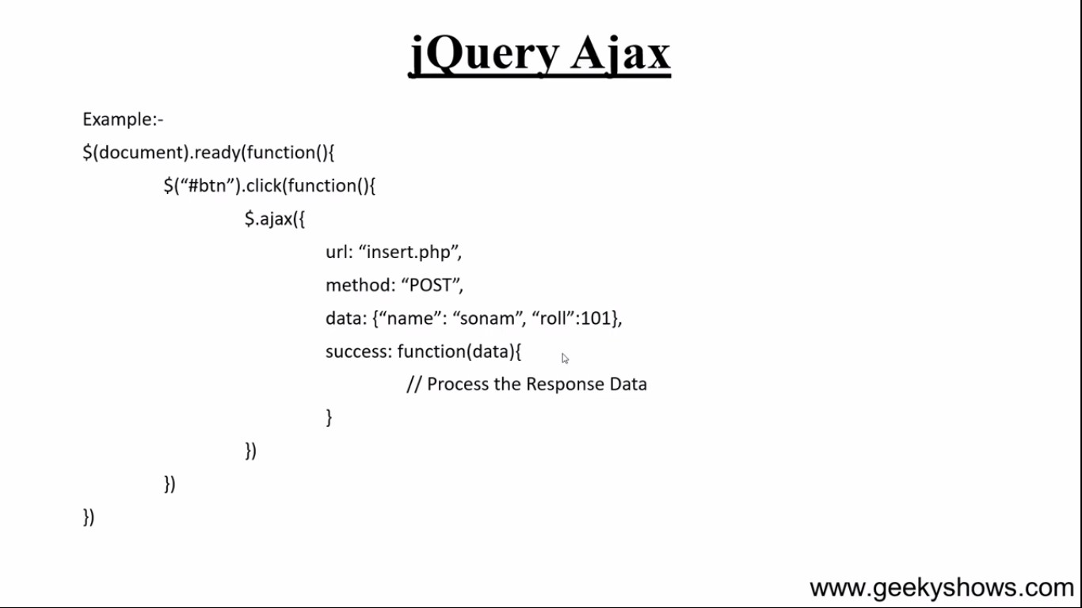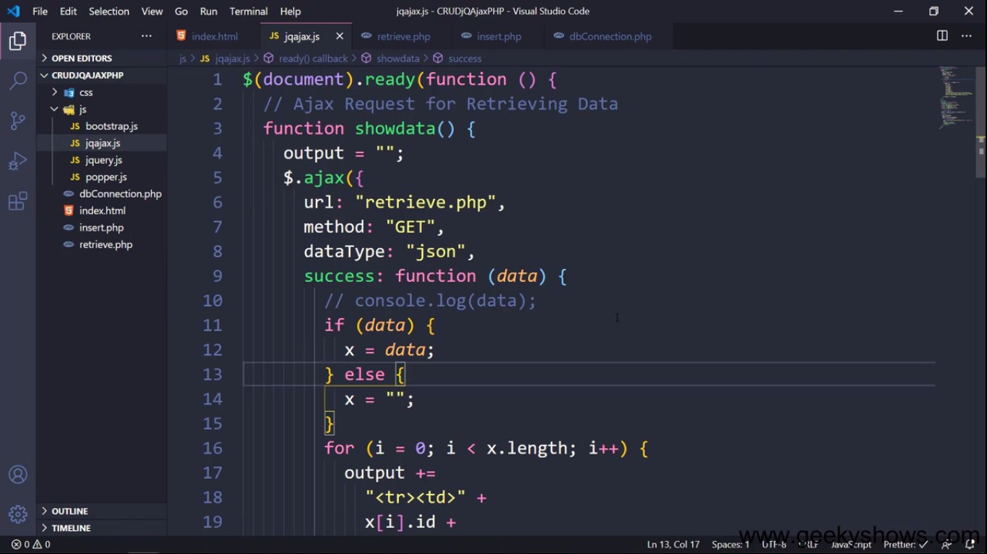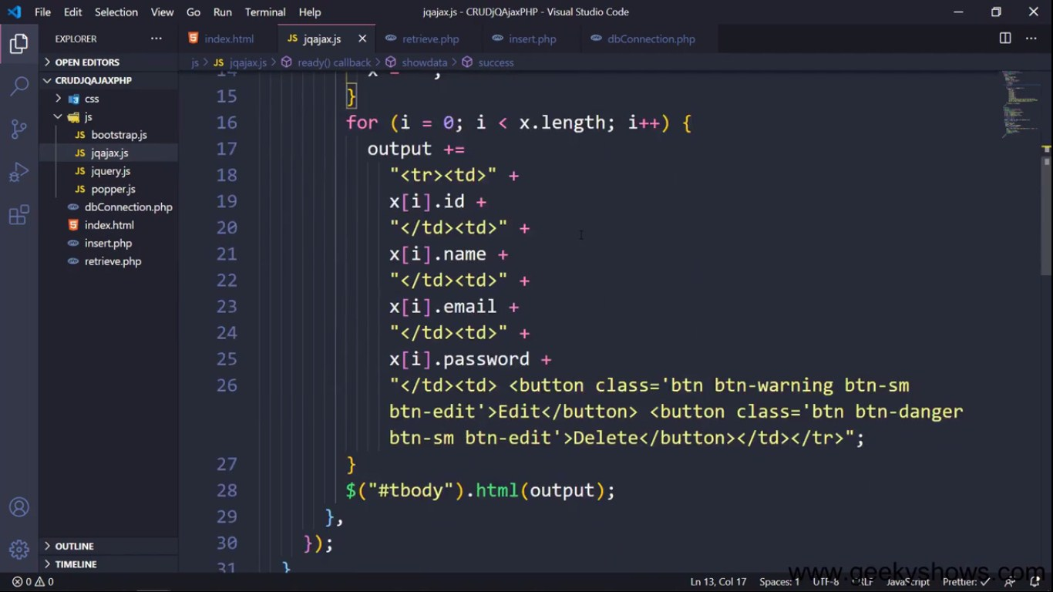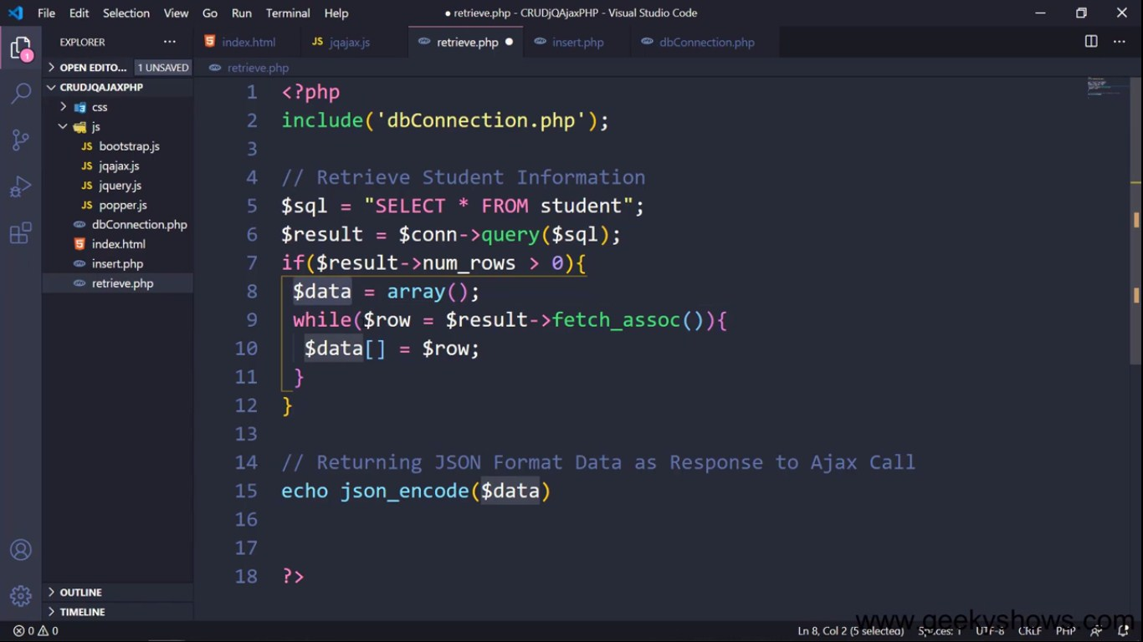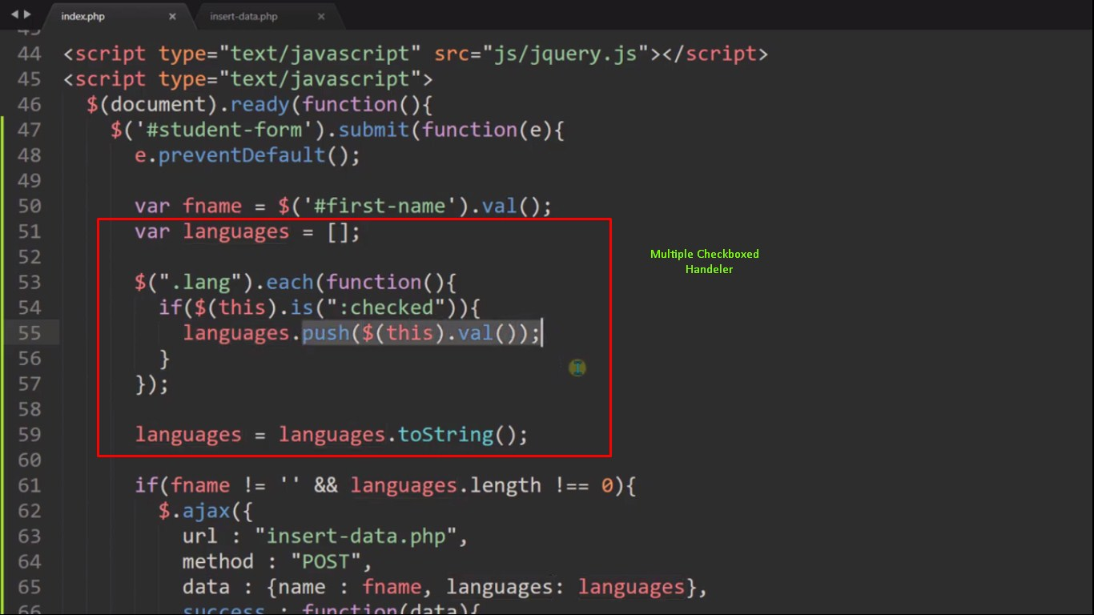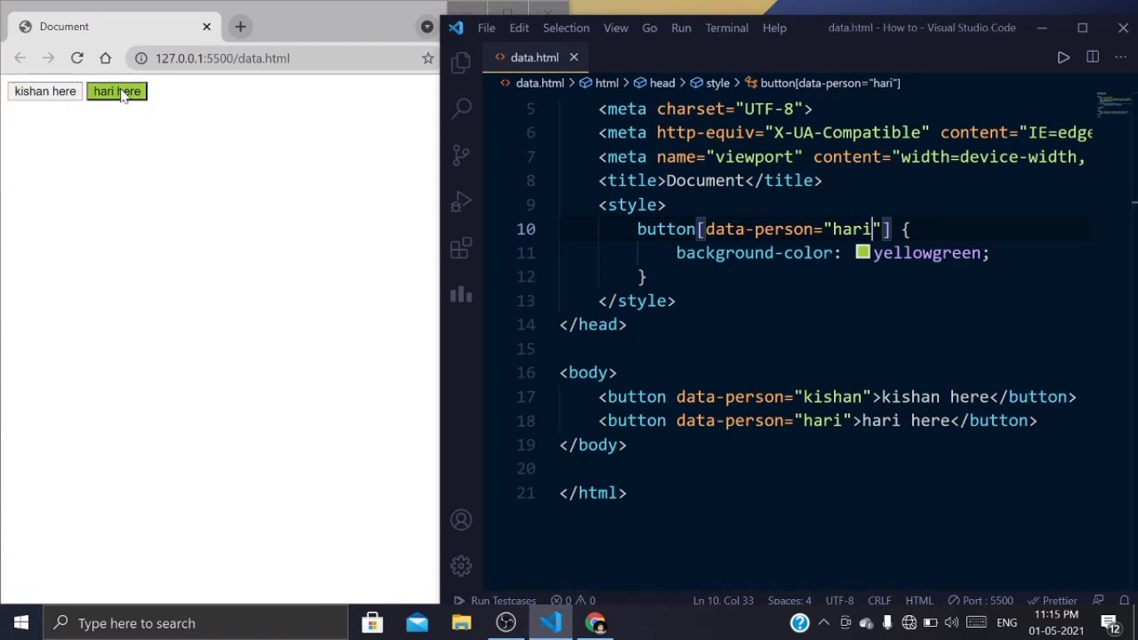

**Basic Gutenberg Block Development**

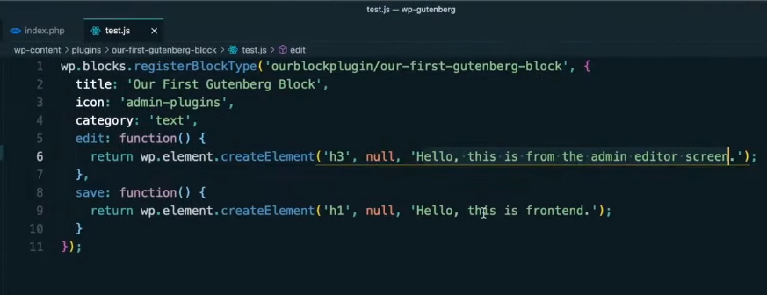

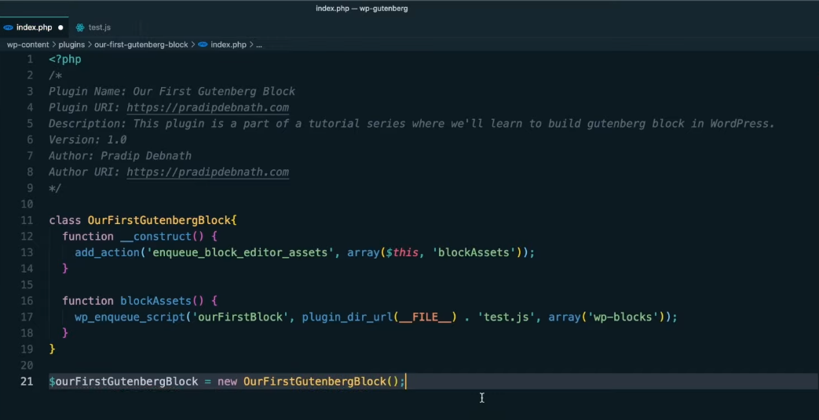

**Richtext Block**

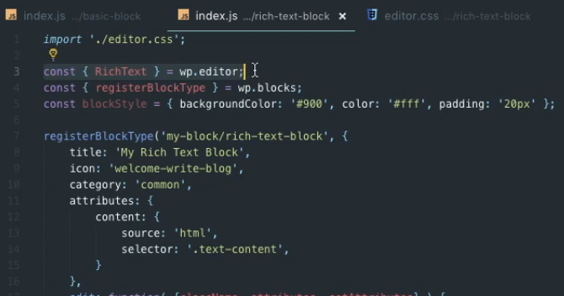

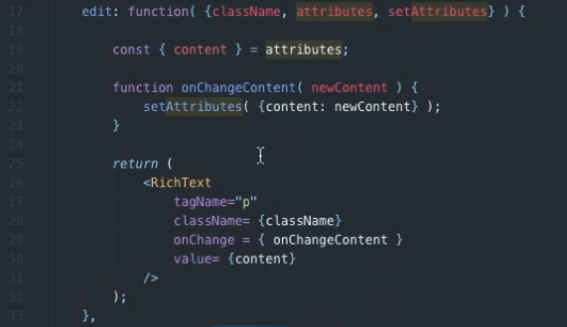

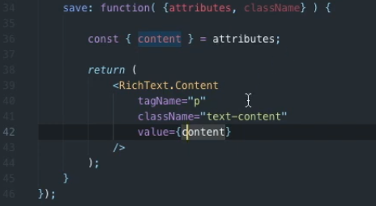

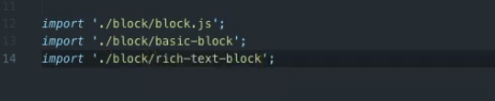

**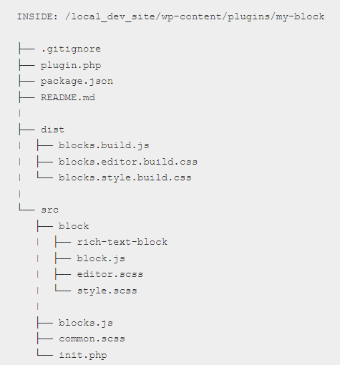**

**Another example**

**registerBlockType('namespace/richtext-block', {**

**title: \_\_('RichText Block'),**

**description: \_\_('A simple block using the RichText element'),**

**icon: 'shield',**

**category: 'common',**

**keywords: [**

**\_\_('richtext-block'),**

**\_\_('RichText Block'),**

**\_\_('RichText')**

**],**

**attributes: {**

**content: {**

**type: 'array',**

**source: 'children',**

**selector: 'h2',**

**},**

**},**

**edit: function ({ attributes, setAttributes, className, isSelected }) {**

**return (**

**<RichText**

**tagName="h2"**

**className={className}**

**value={attributes.content}**

**onChange={(content) => setAttributes({ content })}**

**placeholder={\_\_('Enter text...', 'custom-block')}**

**keepPlaceholderOnFocus={true}**

**/>**

**);**

**},**

**save: function( { attributes } ) {**

**return (**

**<RichText.Content tagName="h2" value={ attributes.content } />**

**);**

**}**

**});**

**Slider block**

**<?php**

**/\***

**Plugin Name: Custom Slider Block**

**Description: Custom Gutenberg Slider Block**

**Version: 1.0**

**Author: Your Name**

**\*/**

**// Enqueue your script and styles**

**function custom\_slider\_enqueue\_scripts() {**

**wp\_enqueue\_script(**

**'custom-slider-block',**

**plugins\_url('dist/block.js', \_\_FILE\_\_),**

**array('wp-blocks', 'wp-element', 'wp-editor'),**

**true**

**);**

**}**

**add\_action('enqueue\_block\_editor\_assets', 'custom\_slider\_enqueue\_scripts');**

**block.js code**

**import { registerBlockType } from '@wordpress/blocks';**

**import { InspectorControls } from '@wordpress/editor';**

**import { PanelBody, TextControl } from '@wordpress/components';**

**registerBlockType('custom-slider/slider-block', {**

**title: 'Custom Slider',**

**icon: 'slides',**

**category: 'common',**

**attributes: {**

**slides: {**

**type: 'array',**

**default: [],**

**},**

**},**

**edit: function (props) {**

**const { attributes, setAttributes } = props;**

**return (**

**<div className={props.className}>**

**<InspectorControls>**

**<PanelBody title="Slider Settings">**

**<TextControl**

**label="Add a slide"**

**value=""**

**onChange={(slide) => {**

**const newSlides = [...attributes.slides, slide];**

**setAttributes({ slides: newSlides });**

**}}**

**/>**

**</PanelBody>**

**</InspectorControls>**

**<div className="slider">**

**{/\* Render your slider here \*/}**

**{attributes.slides.map((slide, index) => (**

**<div key={index} className="slide">**

**{slide}**

**</div>**

**))}**

**</div>**

**</div>**

**);**

**},**

**save: function () {**

**// Save your slider content here**

**return null;**

**},**

**});**

**Card block Development**

**const { RichText, MediaUpload, PlainText } = wp.editor;**

**const { registerBlockType } = wp.blocks;**

**const { Button } = wp.components;**

**// Import our CSS files**

**import './style.scss';**

**import './editor.scss';**

**registerBlockType('card-block/main', {**

**title: 'Card',**

**icon: 'heart',**

**category: 'common',**

**attributes: {**

**title: {**

**source: 'text',**

**selector: '.card\_\_title'**

**},**

**body: {**

**type: 'array',**

**source: 'children',**

**selector: '.card\_\_body'**

**},**

**imageAlt: {**

**attribute: 'alt',**

**selector: '.card\_\_image'**

**},**

**imageUrl: {**

**attribute: 'src',**

**selector: '.card\_\_image'**

**}**

**},**

**edit({ attributes, className, setAttributes }) {**

**const getImageButton = (openEvent) => {**

**if(attributes.imageUrl) {**

**return (**

**<img**

**src={ attributes.imageUrl }**

**onClick={ openEvent }**

**className="image"**

**/>**

**);**

**}**

**else {**

**return (**

**<div className="button-container">**

**<Button**

**onClick={ openEvent }**

**className="button button-large"**

**>**

**Pick an image**

**</Button>**

**</div>**

**);**

**}**

**};**

**return (**

**<div className="container">**

**<MediaUpload**

**onSelect={ media => { setAttributes({ imageAlt: media.alt, imageUrl: media.url }); } }**

**type="image"**

**value={ attributes.imageID }**

**render={ ({ open }) => getImageButton(open) }**

**/>**

**<PlainText**

**onChange={ content => setAttributes({ title: content }) }**

**value={ attributes.title }**

**placeholder="Your card title"**

**className="heading"**

**/>**

**<RichText**

**onChange={ content => setAttributes({ body: content }) }**

**value={ attributes.body }**

**multiline="p"**

**placeholder="Your card text"**

**formattingControls={ ['bold', 'italic', 'underline'] }**

**isSelected={ attributes.isSelected }**

**/>**

**</div>**

**);**

**},**

**save({ attributes }) {**

**const cardImage = (src, alt) => {**

**if(!src) return null;**

**if(alt) {**

**return (**

**<img**

**className="card\_\_image"**

**src={ src }**

**alt={ alt }**

**/>**

**);**

**}**

**// No alt set, so let's hide it from screen readers**

**return (**

**<img**

**className="card\_\_image"**

**src={ src }**

**alt=""**

**aria-hidden="true"**

**/>**

**);**

**};**

**return (**

**<div className="card">**

**{ cardImage(attributes.imageUrl, attributes.imageAlt) }**

**<div className="card\_\_content">**

**<h3 className="card\_\_title">{ attributes.title }</h3>**

**<div className="card\_\_body">**

**{ attributes.body }**

**</div>**

**</div>**

**</div>**

**);**

**}**

**});**

**Custom Block" with a simple text field to the Gutenberg editor.**

**Create a Plugin Directory**:

Create a directory for your custom Gutenberg block plugin in the **wp-content/plugins/** directory of your WordPress installation. Name it something like **custom-gutenberg-block**.

**Inside your plugin directory, create the main PHP file (e.g., custom-gutenberg-block.php) and add the following code**:

**<?php**

**/\***

**Plugin Name: Custom Gutenberg Block**

**Description: A simple custom Gutenberg block example.**

**\*/**

**// Register the block script and style.**

**function custom\_gutenberg\_block\_enqueue() {**

**wp\_enqueue\_script(**

**'custom-gutenberg-block',**

**plugin\_dir\_url(\_\_FILE\_\_) . 'block.js',**

**array('wp-blocks', 'wp-editor'),**

**filemtime(plugin\_dir\_path(\_\_FILE\_\_) . 'block.js')**

**);**

**wp\_enqueue\_style(**

**'custom-gutenberg-block',**

**plugin\_dir\_url(\_\_FILE\_\_) . 'style.css',**

**array('wp-edit-blocks'),**

**filemtime(plugin\_dir\_path(\_\_FILE\_\_) . 'style.css')**

**);**

**}**

**add\_action('enqueue\_block\_editor\_assets', 'custom\_gutenberg\_block\_enqueue');**

We enqueue the JavaScript and CSS files needed for our custom block. The JavaScript file (**block.js**) will define the block's behavior, and the CSS file (**style.css**) will provide styling.

**Create the JavaScript File (block.js)**:

Inside your plugin directory, create a **block.js** file with the following code:

**<script>**

**(function() {**

**var el = wp.element.createElement;**

**var registerBlockType = wp.blocks.registerBlockType;**

**var TextControl = wp.components.TextControl;**

**var RichText = wp.editor.RichText;**

**registerBlockType('custom-gutenberg-block/custom-block', {**

**title: 'Custom Block',**

**icon: 'shield',**

**category: 'common',**

**attributes: {**

**content: {**

**type: 'string',**

**default: 'Hello, Custom Block!'**

**}**

**},**

**edit: function(props) {**

**return el(**

**'div',**

**{},**

**el(**

**TextControl,**

**{**

**value: props.attributes.content,**

**onChange: function(newContent) {**

**props.setAttributes({ content: newContent });**

**},**

**placeholder: 'Enter your custom content here...'**

**}**

**)**

**);**

**},**

**save: function(props) {**

**return el(RichText.Content, {**

**tagName: 'p',**

**value: props.attributes.content**

**});**

**}**

**});**

**})();**

**</script>**

This JavaScript code registers a custom block named "Custom Block" with a text field for entering content.

**Create the CSS File (style.css)**:

Inside your plugin directory, create a **style.css** file to add custom styling for your block.

**Activate the Plugin**:

In the WordPress admin dashboard, navigate to the "Plugins" section and activate your "Custom Gutenberg Block" plugin.

**Use the Custom Block**:

In the Gutenberg editor, you should now see a "Custom Block" in the "Common" category. Add the block to your post or page and use the text field to enter your custom content.

**Custom Gutenberg block in JSX procedure**

Creating a custom Gutenberg block in JSX involves several steps, as Gutenberg block development primarily relies on JavaScript, especially JSX, which is a JavaScript syntax extension often used with React. Here's a step-by-step procedure to create a custom Gutenberg block in JSX:

**Prerequisites:**

1.You should have a development environment set up with Node.js and npm installed.

2.Familiarity with JavaScript, React, and JSX is beneficial.

**Procedure:**

1. **Create a WordPress Plugin Directory**:

Start by creating a new directory for your custom Gutenberg block plugin in the **wp-content/plugins/** directory of your WordPress installation. Name it something like **custom-gutenberg-block**.

1. **Inside your plugin directory, create the main PHP file (e.g., custom-gutenberg-block.php) and add the following code**:

**<?php**

**/\***

**Plugin Name: Custom Gutenberg Block**

**Description: A custom Gutenberg block developed with JSX.**

**\*/**

**// Enqueue the JavaScript file containing your block.**

**function enqueue\_custom\_block() {**

**wp\_enqueue\_script(**

**'custom-gutenberg-block',**

**plugin\_dir\_url(\_\_FILE\_\_) . 'build/index.js',**

**array('wp-blocks', 'wp-editor'),**

**filemtime(plugin\_dir\_path(\_\_FILE\_\_) . 'build/index.js')**

**);**

**}**

**add\_action('enqueue\_block\_editor\_assets', 'enqueue\_custom\_block');**

we're enqueuing the JavaScript file (**index.js**) that contains our custom block.

**Set Up Your JavaScript Development Environment**:

You'll need a development environment to write and compile JSX into JavaScript. You can use tools like Webpack and Babel for this purpose. Create a **src** directory in your plugin folder for your JavaScript source files.

**Create a JSX File for Your Block**:

Inside the **src** directory, create a JSX file for your custom block (e.g., **custom-block.js**). Here's a simplified example:

**const { registerBlockType } = wp.blocks;**

**const { TextControl } = wp.components;**

**registerBlockType('custom-gutenberg-block/custom-block', {**

**title: 'Custom Block',**

**icon: 'shield',**

**category: 'common',**

**attributes: {**

**content: {**

**type: 'string',**

**default: 'Hello, Custom Block!',**

**},**

**},**

**edit: function (props) {**

**return (**

**<div>**

**<h2>Custom Gutenberg Block</h2>**

**<TextControl**

**label="Enter custom content"**

**value={props.attributes.content}**

**onChange={(newContent) => props.setAttributes({ content: newContent })}**

**/>**

**</div>**

**);**

**},**

**save: function (props) {**

**return <p>{props.attributes.content}</p>;**

**},**

**});**

This JSX code registers a custom block that includes a simple text input field.

**Compile JSX to JavaScript**:

Use a build tool like Webpack and Babel to compile your JSX code into JavaScript. You'll need to configure your build process to output the compiled JavaScript file into a directory like **build**. Ensure that your compiled JavaScript file is named **index.js**.

**Activate the Plugin and Use the Block**:

In your WordPress admin dashboard, activate the "Custom Gutenberg Block" plugin. You can then use the "Custom Block" in the Gutenberg editor.

**Custom Gutenberg block development Node Js procedure**

Creating custom Gutenberg blocks in WordPress allows you to extend the functionality of the Gutenberg block editor by adding your own custom blocks with unique features. Here is a step-by-step procedure for developing a custom Gutenberg block:

**Step 1: Set Up Your Development Environment**

1.A local or remote WordPress installation.

2.A code editor for writing JavaScript, CSS, and PHP code.

3.Node.js and npm (Node Package Manager) installed on your computer.

**Step 2: Create a New WordPress Plugin**

Custom Gutenberg blocks are typically packaged as WordPress plugins. Create a new directory for your plugin inside the **wp-content/plugins/** directory of your WordPress installation. Name it something unique and descriptive, like "my-custom-gutenberg-block."

Inside your plugin directory, create a main PHP file, e.g., **my-custom-gutenberg-block.php**. This file will serve as the entry point for your plugin.

**Step 3: Initialize Your Plugin**

In your main PHP file (**my-custom-gutenberg-block.php**), start by defining the basic plugin information and initializing it. Here's a minimal example:

**<?php**

**/\*\***

**\* Plugin Name: My Custom Gutenberg Block**

**\* Description: A custom Gutenberg block for WordPress.**

**\* Version: 1.0**

**\* Author: Your Name**

**\*/**

**// Initialize your plugin here.**

**Step 4: Set Up the Block Development Environment**

To build and manage your custom Gutenberg block, you'll need to set up a development environment using npm and the WordPress scripts package. Open your terminal, navigate to your plugin's directory, and run the following commands:

**npm init -y**

**npm install @wordpress/scripts --save-dev**

Create a **src** directory inside your plugin directory to store your block's JavaScript files.

**Step 5: Create the Block JavaScript File**

Inside the **src** directory, create a JavaScript file for your block, e.g., **my-custom-block.js**. This file will contain the JavaScript code for your block.

**Step 6: Define Your Block**

In your block JavaScript file (**my-custom-block.js**), define your custom block using the WordPress block development API. Here's a simplified example of a custom block that displays a "Hello, Gutenberg!" message:

**// Import necessary dependencies**

**import { registerBlockType } from '@wordpress/blocks';**

**import { TextControl } from '@wordpress/components';**

**// Register the block**

**registerBlockType('my-custom-gutenberg-block/hello-gutenberg', {**

**title: 'Hello Gutenberg Block',**

**icon: 'smiley',**

**category: 'common',**

**attributes: {**

**message: {**

**type: 'string',**

**default: 'Hello, Gutenberg!',**

**},**

**},**

**edit: function(props) {**

**return (**

**<div>**

**<TextControl**

**label="Message"**

**value={props.attributes.message}**

**onChange={message => props.setAttributes({ message })}**

**/>**

**</div>**

**);**

**},**

**save: function() {**

**return null; // The block's content is saved on the server.**

**},**

**});**

* We import the necessary WordPress block development functions and components.
* We register the custom block using the **registerBlockType** function.
* The block has a title, icon, and is categorized under "Common."
* It has a single attribute named "message" for the block's content.
* The **edit** function defines the block's editing interface using JSX (React).
* The **save** function is empty because the block's content is saved on the server.

**Step 7: Build and Enqueue Your Block JavaScript**

Back in your terminal, run the following command to build your block JavaScript:

**npm run build**

This command generates a production-ready JavaScript file in the **build** directory of your plugin.

Next, enqueue the block JavaScript in your plugin's PHP file (**my-custom-gutenberg-block.php**). You can use the **wp\_enqueue\_script** function:

**function my\_custom\_gutenberg\_block\_enqueue() {**

**wp\_enqueue\_script(**

**'my-custom-gutenberg-block',**

**plugins\_url('build/my-custom-block.js', \_\_FILE\_\_),**

**array('wp-blocks', 'wp-components', 'wp-editor'),**

**filemtime(plugin\_dir\_path(\_\_FILE\_\_) . 'build/my-custom-block.js')**

**);**

**}**

**add\_action('enqueue\_block\_editor\_assets','my\_custom\_gutenberg\_block\_enqueue');**

This code enqueues your block's JavaScript and its dependencies for use in the Gutenberg editor.

**Step 8: Activate Your Plugin**

Activate your custom plugin through the WordPress admin dashboard.

**Step 9: Add Your Custom Block in Gutenberg**

After activation, you can add your custom block to any post or page using the Gutenberg block editor. Search for your block's title ("Hello Gutenberg Block" in this example) and add it to the content. You can then configure and customize the block as needed.

**Step 10: Further Development and Styling**

From here, you can further develop your custom Gutenberg block by adding additional attributes, settings, and styling using CSS. You can also integrate server-side functionality to save and retrieve block data

Top of Form

**Custom block for Elementor Pro**

Developing a custom block for Elementor Pro involves creating a custom widget that integrates seamlessly with the Elementor page builder. Elementor provides a framework for building custom widgets that you can use to add new elements or functionality to your pages. Below are the steps to develop a custom block for Elementor Pro:

**Step 1: Set Up Your Development Environment**

Before you start, make sure you have the following tools and environment set up:

\*WordPress installed with Elementor Pro.

\*A code editor for writing PHP, CSS, and JavaScript.

\*Access to your server's file system or an environment where you can create and upload files.

**Step 2: Create a Plugin for Your Custom Block**

To keep your custom block organized, it's a good practice to create a custom plugin for it. Create a new directory in your WordPress plugins folder (usually located at **wp-content/plugins/**) and give it a unique name. Inside this directory, create a PHP file to initialize your plugin.

For example, you can create a file named **custom-elementor-block.php** with the following content:

<?php

/\*

Plugin Name: Custom Elementor Block

Description: A custom Elementor Pro block.

Version: 1.0

Author: Your Name

\*/

// Define plugin functionality here.

**Step 3: Define the Custom Widget Class**

To create your custom block, you'll need to define a custom widget class that extends the **\Elementor\Widget\_Base** class. This class should be placed within your plugin file or a separate PHP file included by your plugin file.

Here's a basic example:

**class Custom\_Elementor\_Block\_Widget extends \Elementor\Widget\_Base {**

**public function get\_name() {**

**return 'custom-elementor-block'; // The name of your widget.**

**}**

**public function get\_title() {**

**return 'Custom Elementor Block'; // The title displayed in the Elementor editor.**

**}**

**public function get\_icon() {**

**return 'fa fa-code'; // The icon for your block (Font Awesome icon class).**

**}**

**public function get\_categories() {**

**return ['general']; // The category in which your block will appear.**

**}**

**protected function \_register\_controls() {**

**// Define your widget controls (settings) here.**

**}**

**protected function render() {**

**// Define how your block should be displayed on the front end here.**

**}**

**}**

**// Register the widget**

**\Elementor\Plugin::instance()->widgets\_manager->register\_widget\_type(new Custom\_Elementor\_Block\_Widget());**

This code creates a basic widget class with essential properties and methods. You will need to customize it to suit your specific block's functionality.

**Step 4: Define Widget Controls (Settings)**

In the **\_register\_controls** method of your widget class, define the settings (controls) for your custom block. These controls allow users to configure the block's appearance and behavior in the Elementor editor. Elementor provides various control types, such as text fields, color pickers, and image selectors. Here's an example of how to define a text control:

**protected function \_register\_controls() {**

**$this->start\_controls\_section(**

**'section\_content',**

**[**

**'label' => \_\_('Content', 'your-text-domain'),**

**]**

**);**

**$this->add\_control(**

**'custom\_text',**

**[**

**'label' => \_\_('Custom Text', 'your-text-domain'),**

**'type' => \Elementor\Controls\_Manager::TEXT,**

**'default' => \_\_('Hello, World!', 'your-text-domain'),**

**]**

**);**

**$this->end\_controls\_section();**

**}**

**Step 5: Define the Frontend Output**

In the **render** method of your widget class, define how your custom block should be displayed on the front end of the website. You can use PHP and HTML to generate the block's output. Here's a simple example:

**protected function render() {**

**$settings = $this->get\_settings\_for\_display();**

**echo '<div class="custom-elementor-block">';**

**echo '<p>' . esc\_html($settings['custom\_text']) . '</p>';**

**echo '</div>';**

**}**

**Step 6: Style Your Block**

To ensure your block looks good on the front end, you can add custom CSS styles using Elementor's built-in styling options or by enqueuing an external stylesheet.

**Step 7: Test Your Custom Block**

Activate your custom plugin, and you should be able to add your custom block to Elementor pages by searching for it in the Elementor editor's widget panel. Configure the block's settings, add it to your page, and preview it to ensure it works as expected.

**Step 8: Refine and Document**

Test your block thoroughly, make any necessary refinements, and document its usage and customization options for users or other developers.

This is a basic guide to creating a custom block for Elementor Pro. Depending on your requirements, you may need to implement additional features, such as dynamic content, dynamic tags, and advanced controls. Be sure to consult the Elementor developer documentation for detailed information on creating custom blocks and widgets: [Elementor Developers Documentation](https://developers.elementor.com/).

**WP-CLI**

**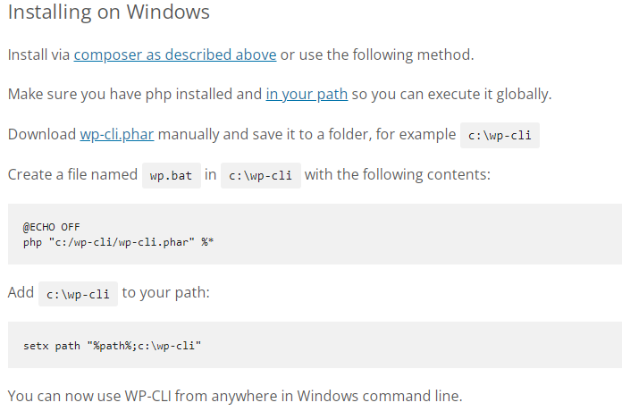**

**Environment variable path setting example:**

**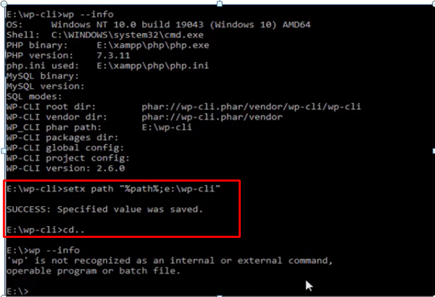**

**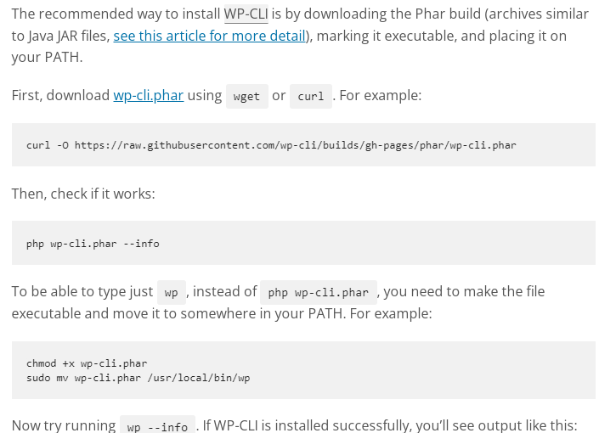**

**wp+ enter key (wp help command) for showing all command**

**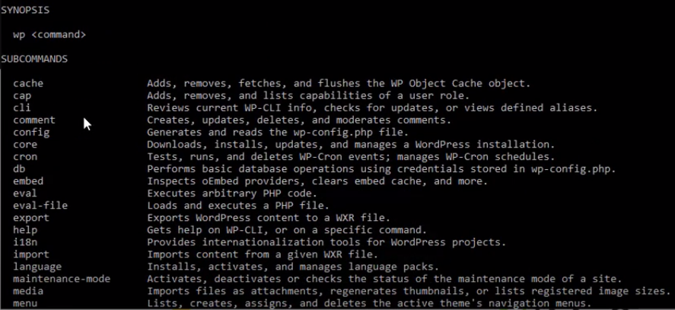**

**Sub command**

**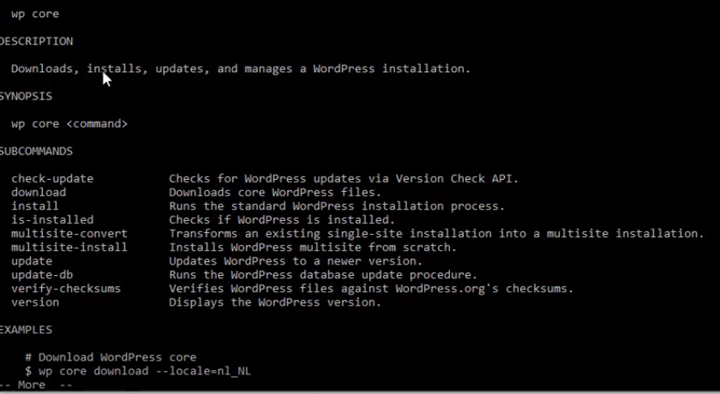**

**a**

**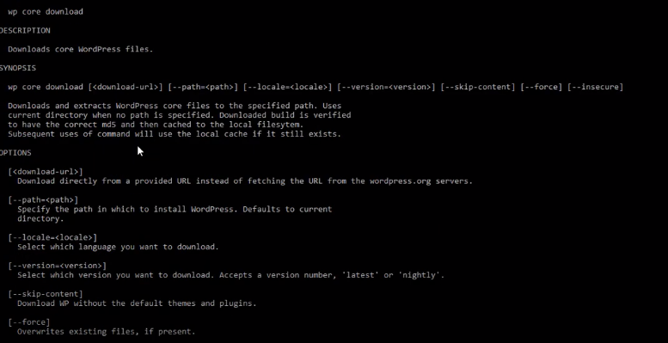**

**Downloading example**

**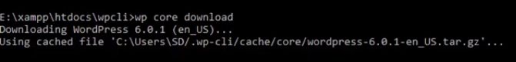**

**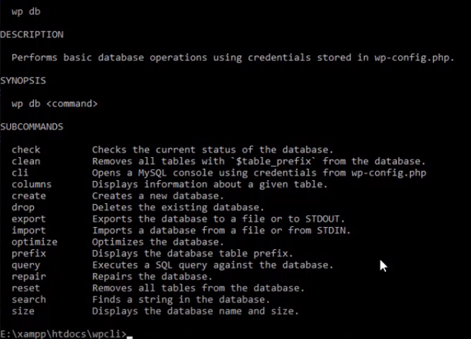**

**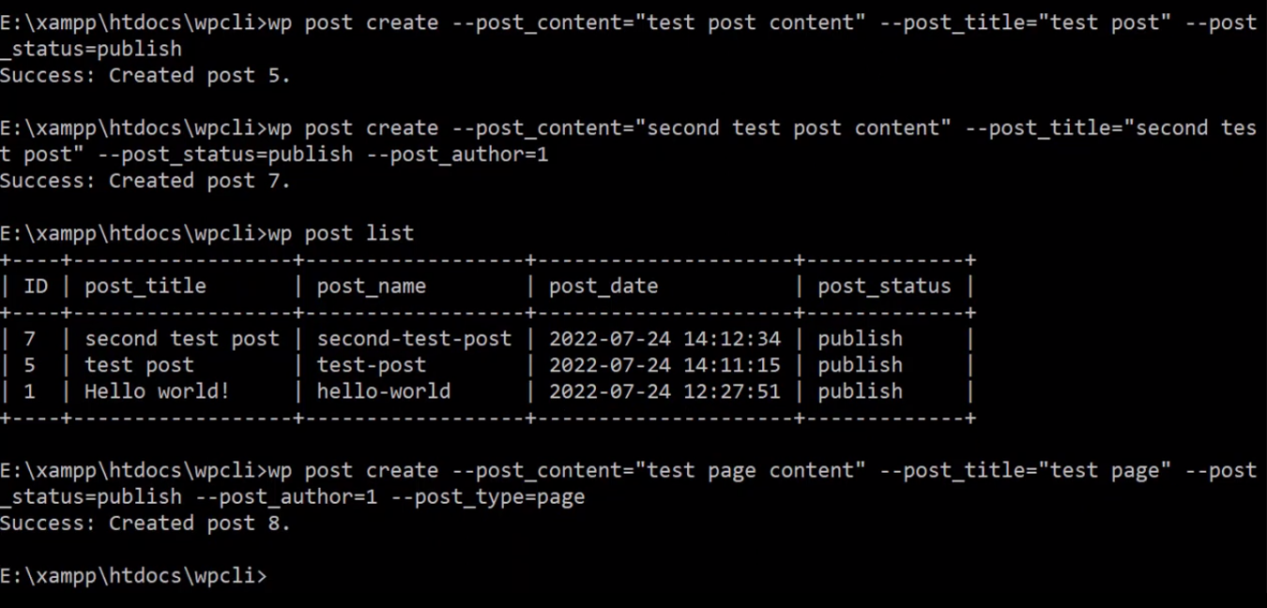**

**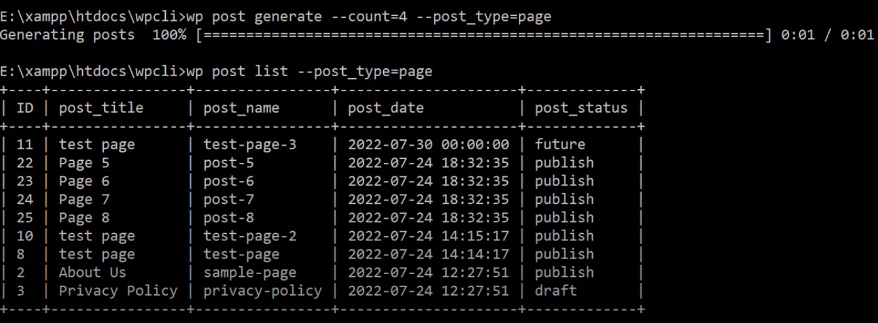**

**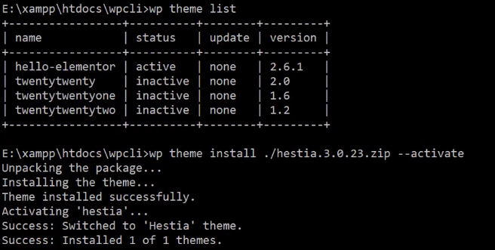**

**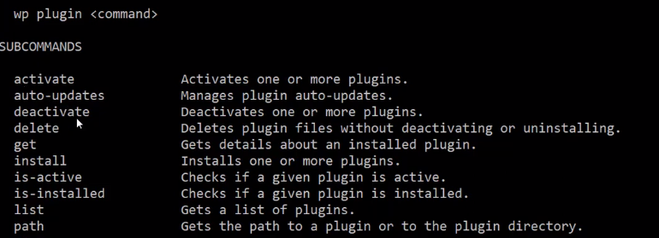**

**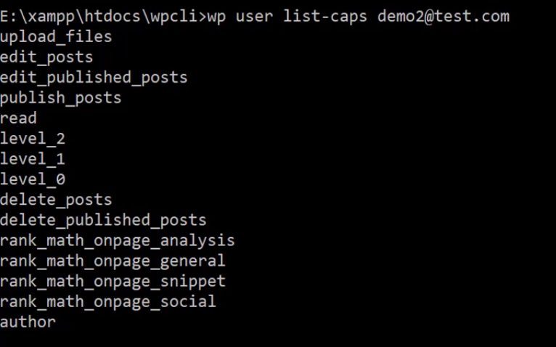**

**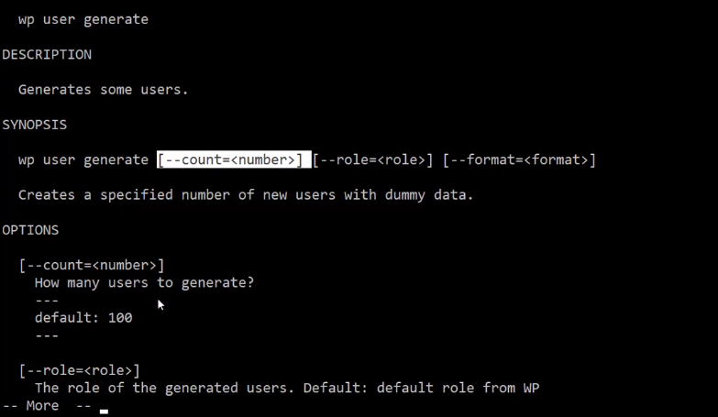**

**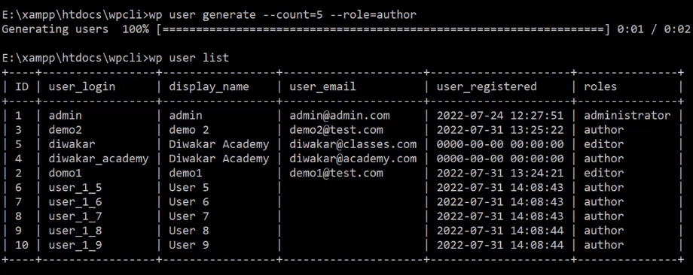**

**WP CLI several benefits for developers, site administrators, and anyone who works with WordPress:**

**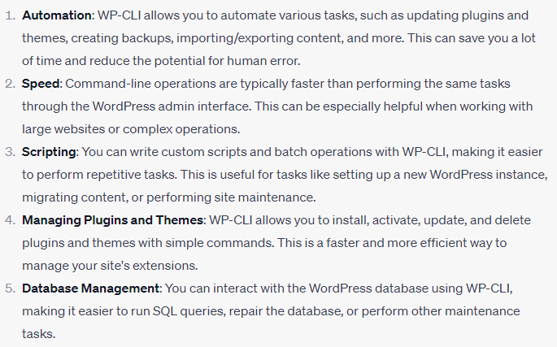**

**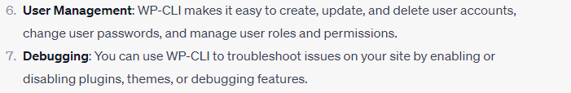**

**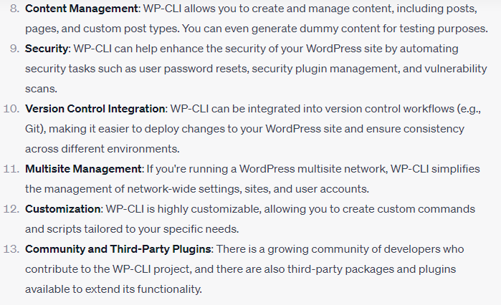**

**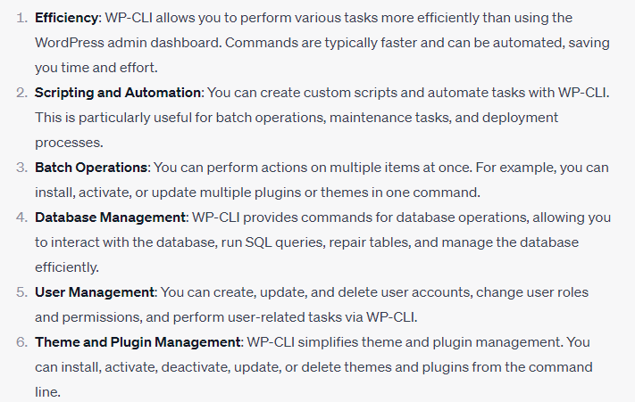**

**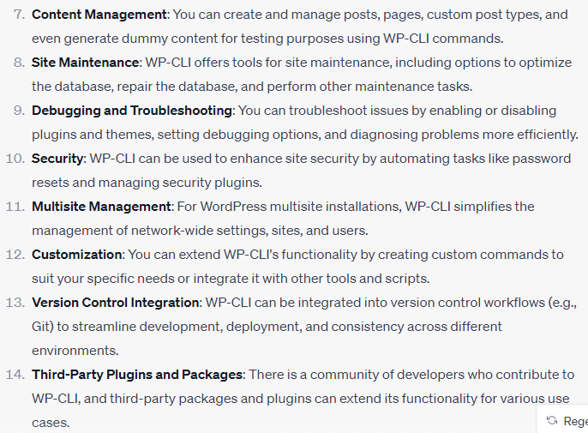**

**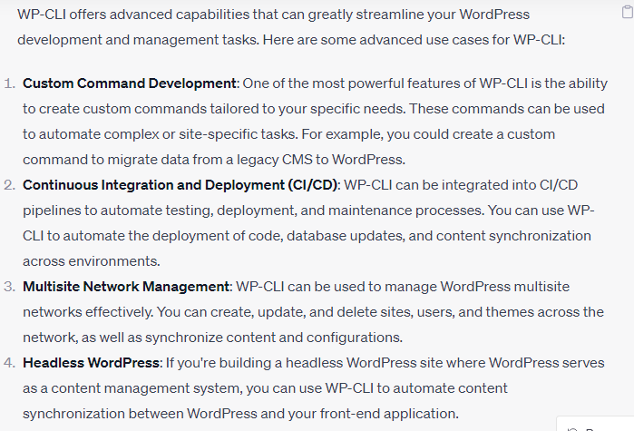**

**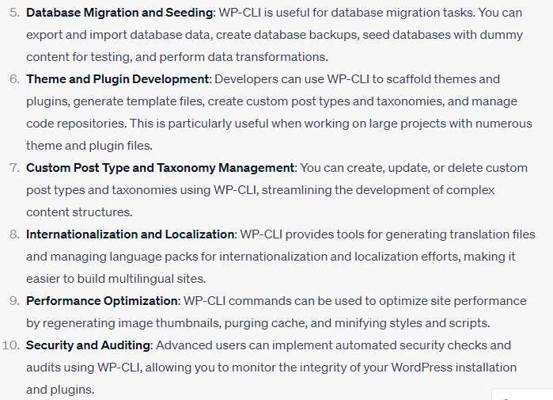**

**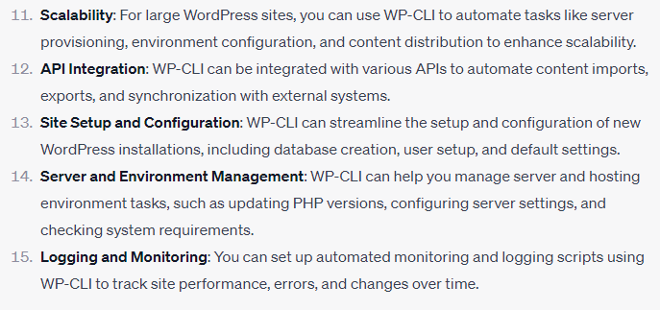**

**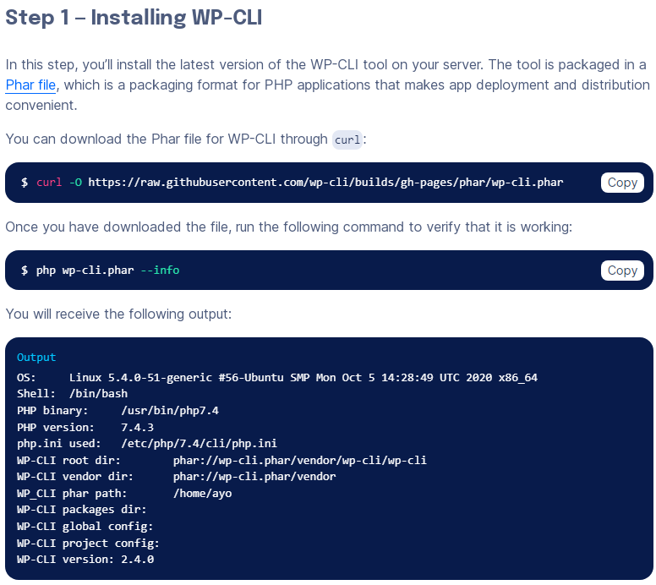**

**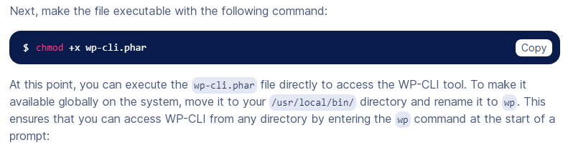**

**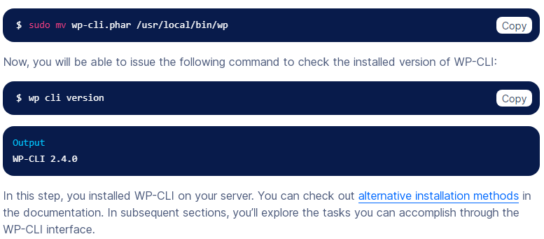**

**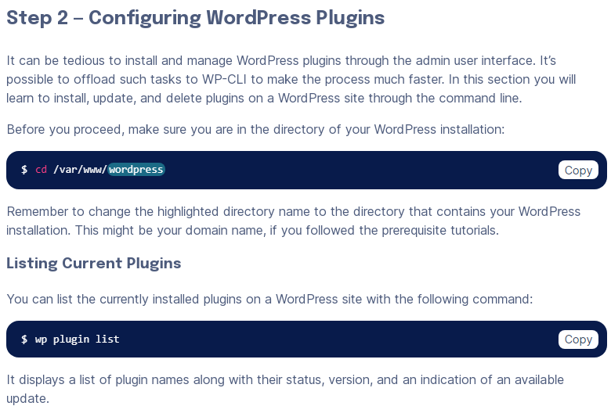**

**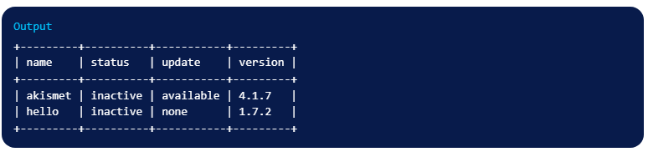**

**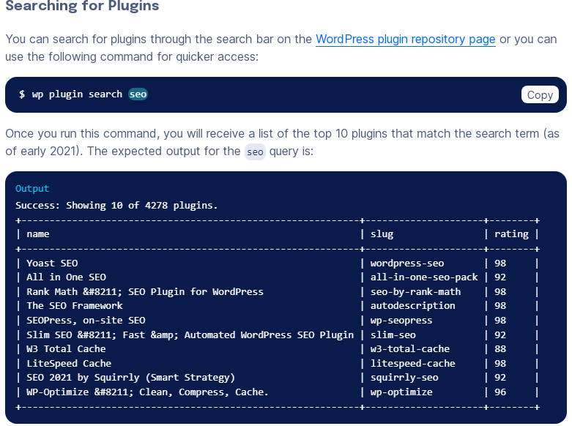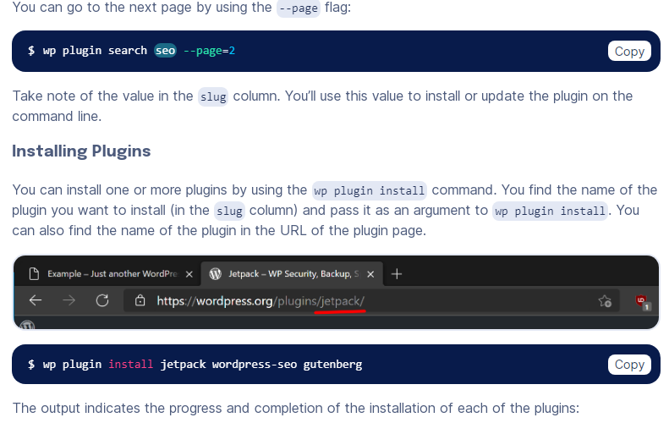**

**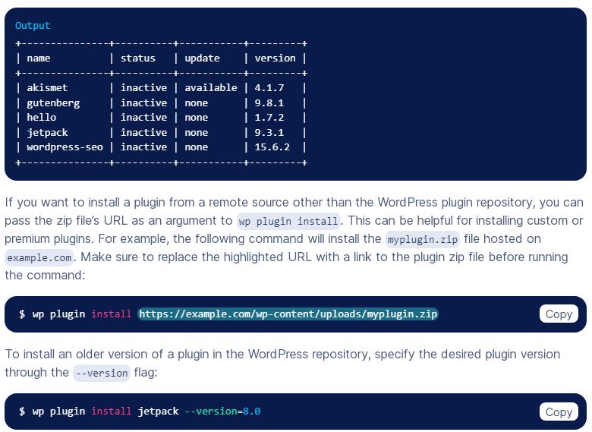 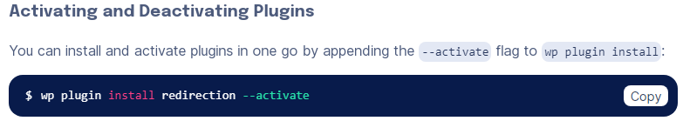 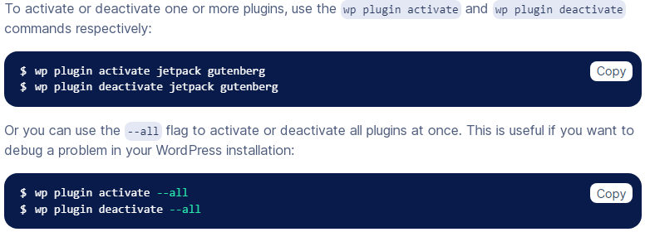**

**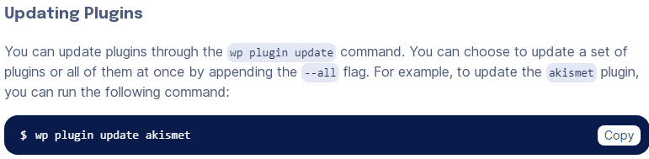 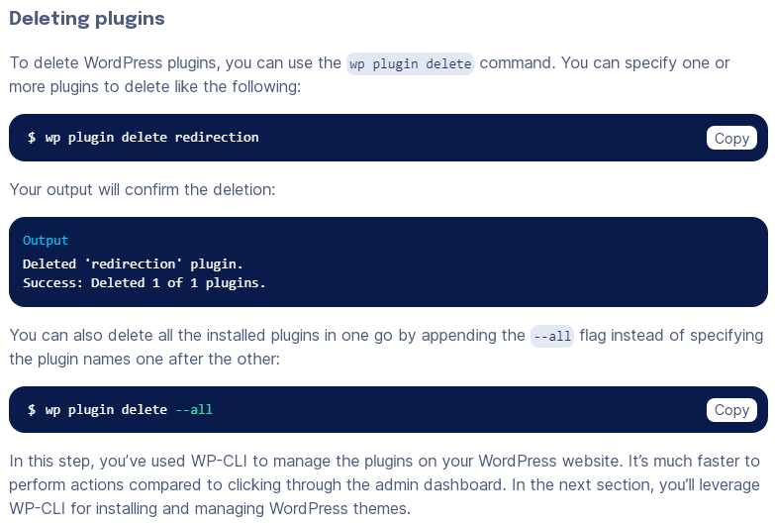 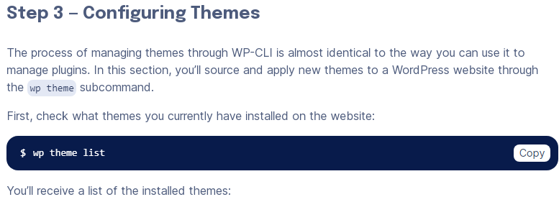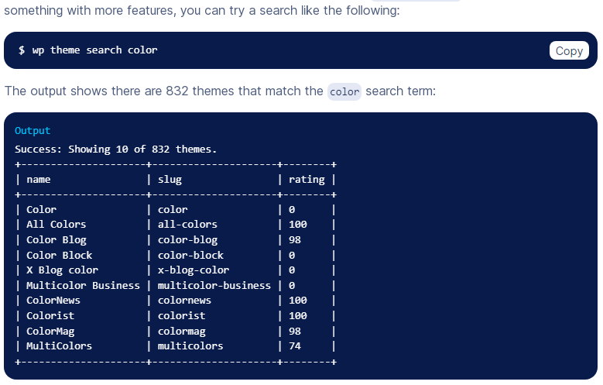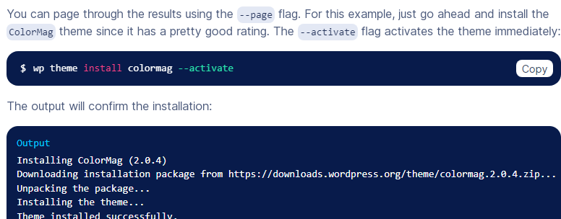**

****

**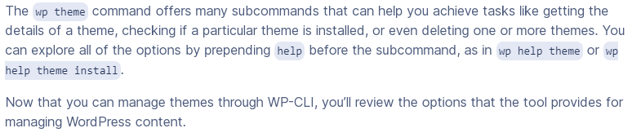**

**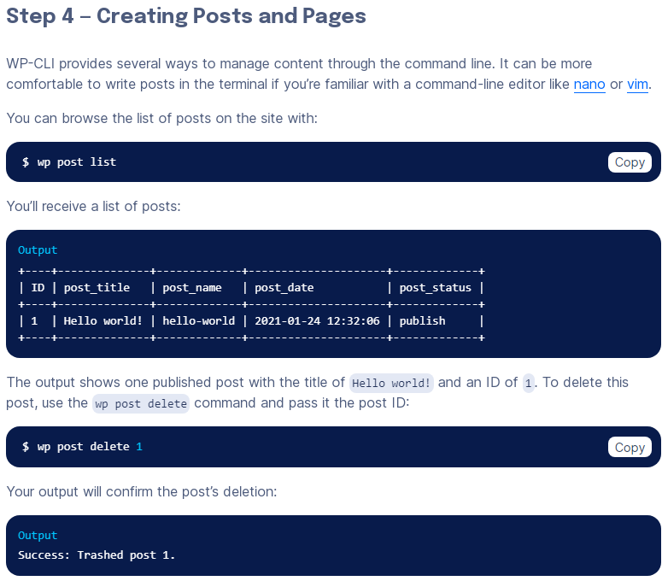 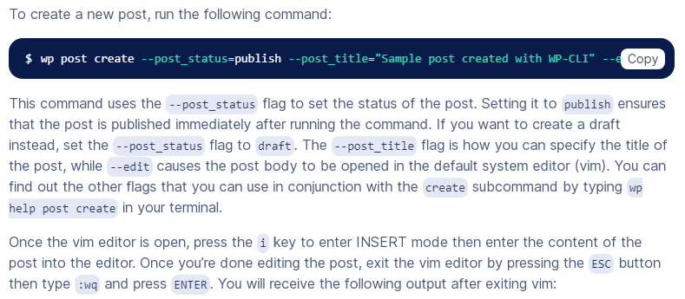 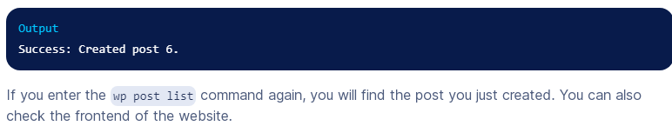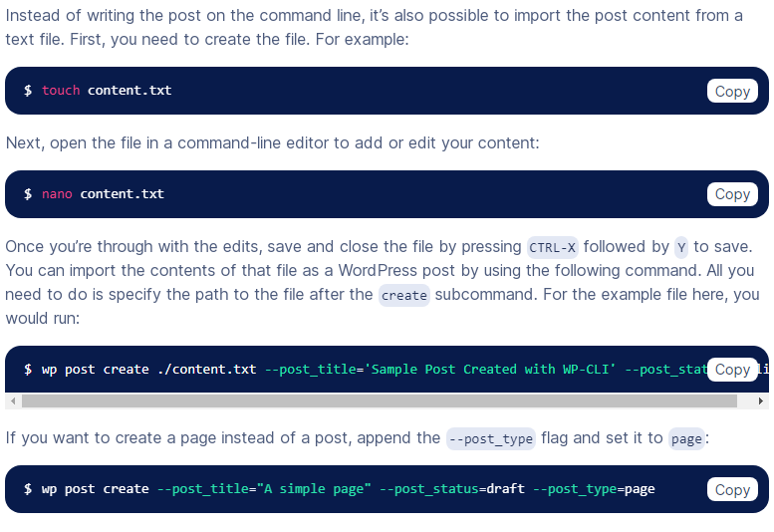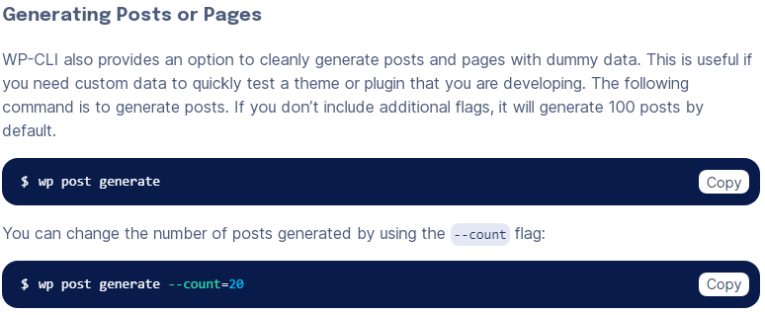**

**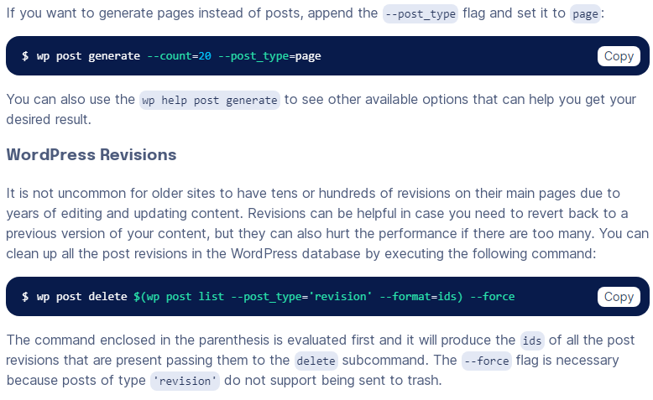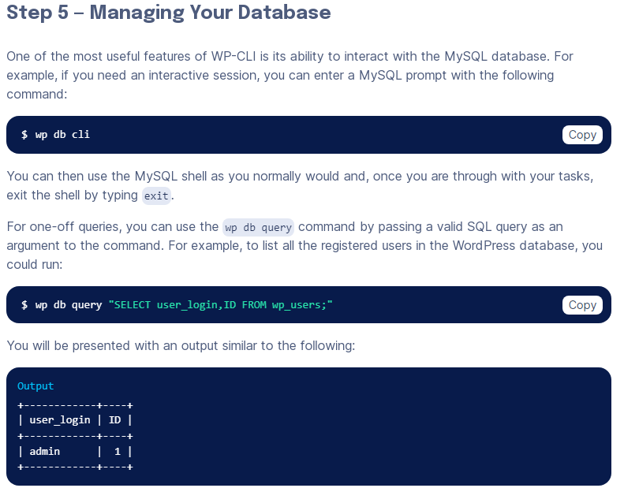**

****

**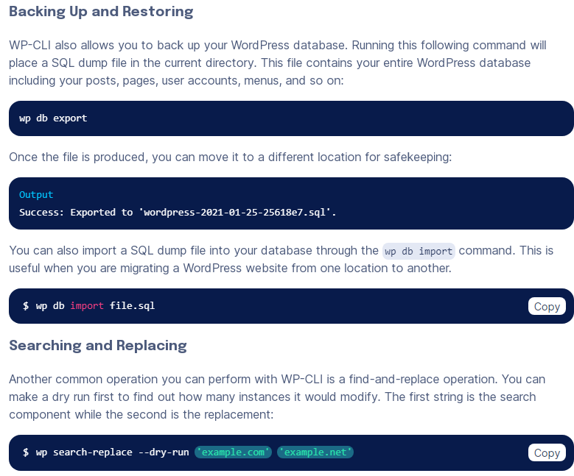**

**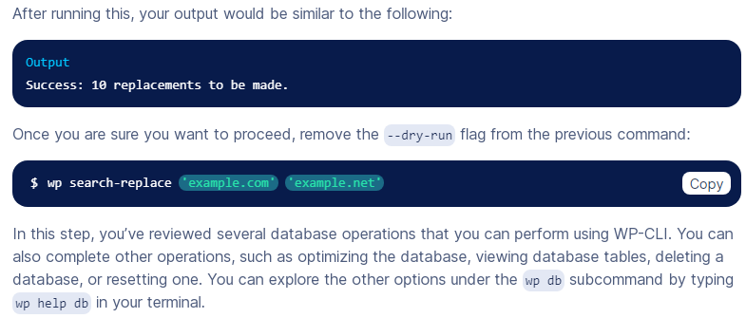**

**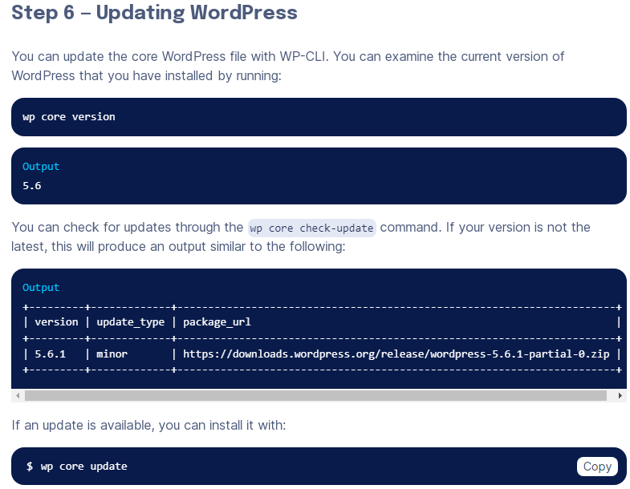**

**Dev OPS Another**

**

